

Submitted in part fulfilment for the degree of MSc Computer Science

**Accessibility and Its Impact on University Web Engagement:   
A UK Perspective**

Iveta Pudilova

16 August 2024  
Independent Research Project  
COM00151M

Word count: 8,665

Supervisor: Tina Baker

# Executive Summary

This study examines the relationship between user engagement and website accessibility across 57 university homepages in the United Kingdom, with a particular focus on Russell Group and ex-polytechnic universities. The study aims to determine the most frequent online accessibility issues, evaluate the accessibility and user engagement of these homepages, and investigate any potential relationships between the two variables.

This research is motivated by the Public Sector Bodies (Websites and Mobile Applications) Accessibility Regulations 2018 (PSBAR), which legally require universities to provide accessible digital information. Additionally, with 19% of UK university students reporting a disability, it is also an ethical imperative to support inclusive education practices. Inadequate accessibility may result in fines, reputational harm, and legal consequences. Furthermore, websites that are accessible are essential for increasing user engagement, which has a favourable effect on student applications.

Quantitative methods were used in the investigation. Accessibility was determined using automated tools WAVE and AChecker. SimilarWeb was used to collect engagement metrics: bounce rate, pages per session, and visit length. A manual review of accessibility statements was conducted to ensure their contents comply with the law. Linear regression and correlation analysis were employed to investigate the relationship between accessibility and engagement.

The findings showed that, although ex-polytechnic universities generally outperformed Russell Group in terms of engagement, both groups displayed comparable patterns of accessibility issues. The most frequent accessibility violations were missing picture alt text and low contrast errors.

The correlation analysis showed that accessibility and engagement had weak correlations. Some stronger correlations were found by regression analysis, such as a strong negative relationship between Pages per Session and Low Contrast errors, suggesting that increased accessibility could boost user engagement. However, the regression models showed that the majority of accessibility parameters were not statistically significant predictors of engagement. Consequently, the correlation and regression analysis indicated that while there is a relationship between accessibility and engagement, it is minimal, and that engagement may be impacted by a variety of other factors.

Although the study offers insightful information, it also has a number of limitations. The study's sample of Russell Group and ex-polytechnic universities may not accurately reflect the diversity of all UK universities. Furthermore, the study only used automated tools to evaluate accessibility, which are effective but unable to fully capture the spectrum of accessibility problems that disabled users may encounter.

Several professional and ethical considerations were taken into account. Legally, evaluating a university's online accessibility involved investigating to what extent it complied with the PSBAR and possibly pointing out any legal violations. Exposing non-compliance could damage these institutions' reputations on a social, ethical, and commercial level, which could have a negative effect on their brand and student recruitment. Ensuring neutrality and accuracy was imperative from a professional standpoint to prevent any university from being misrepresented.

# 

# Table of Contents

**1. Introduction 9**

1.1. Research Questions 10

1.2. Hypotheses 10

**2. Literature Review 12**

2.1. Disability in Higher Education 12

2.2. The Public Sector Bodies (Websites and Mobile Applications) Accessibility Regulations 2018 15

2.3. State of Digital Accessibility in HEI 16

2.4. Consequences of Digital Accessibility 18

**3. Methodology 23**

3.1. Philosophical Approach 23

3.2. Methodological Approach 23

3.3. Data Science Methodology 24

3.3.1. Selecting Universities 24

3.3.2. Accessibility Evaluation 26

3.3.3. Engagement Evaluation 28

3.3.4. Data Cleaning 28

3.3.5. Analysis 29

**4. Analysis 31**

**5. Results and Findings 31**

5.1. Engagement 31

5.2. Accessibility Level 32

5.2.1. Common Violations 34

5.2.2. Accessibility Features 35

5.3. Accessibility Statements 36

5.4. Accessibility and Engagement 39

5.4.1. Correlation Analysis 39

5.4.2. Regression Analysis 39

**6. Discussion 4****2**

6.1. Engagement 42

6.2. Accessibility 42

6.3. Common Violations 43

6.4. Accessibility Statements 44

6.5. Correlation and Regression Analysis 45

**7. Conclusion 4****8**

7.1. RQs 48

7.1.1. RQ1: What is the current accessibility and engagement level of UK university homepages and the differences between Russell Group versus ex-polytechnic universities, if any? 48

7.1.2. RQ2: What are the most common web accessibility violations on UK university homepages? 49

7.1.3. RQ3: Is there a relationship between the website accessibility of UK universities and their engagement? 49

7.2. Limitations and Further Research 49

**Reference List 5****2**

**Appendices 6****3**

# 

# List of Figures

Figure 1. Number of Disabled Higher Education Students between 2014 and 2023 13

Figure 2. Distribution in Website Traffic Change after Accessibility Enhancement 19

# 

# List of Tables

Table 1. Engagement Levels of Russell Group and Ex-Polytechnic University Websites 32

Table 2. WAVE Accessibility Issues of Russell Group and Ex-Polytechnic University Websites 33

Table 3. AChecker Accessibility Issues Levels of Russell Group and Ex-Polytechnic University Websites 35

Table 4. Criteria A versus AA Accessibility Violations of Russell Group and Ex-Polytechnic University Websites 35

Table 5. Accessibility Features of Russell Group and Ex-Polytechnic University Websites 36

Table 6. Compliance of Website Accessibility Statements of Russell Group and Ex-Polytechnic Universities 37

Table 7. Compliance of Website Accessibility Statements of Russell Group and Ex-Polytechnic Universities 38

# Introduction

Higher Education Institutions (HEI) play an increasingly important role in the digital landscape in this age of digital transformation, one that goes beyond traditional classroom walls. Universities increasingly rely on online platforms for outreach, administration, and education, so it is critical that these platforms be usable by everyone, including those with disabilities. The present thesis explores the relationship between digital accessibility and user engagement on university websites, focusing particularly on the varied landscape of HEI’s in the United Kingdom, including Russell Group Universities and former polytechnic universities.

The need for this research is underscored by the Equality Act 2010 and the PSBAR. This legislation mandates universities to ensure their campus facilities and online platforms are accessible and provide students with reasonable adjustments [[1]](https://paperpile.com/c/zJ6SRg/gDUW). Reasonable adjustments might include extra assessment time, options to take exams in smaller groups, or using laptops during exams for Dyslexic students or those with mobility issues [[2]](https://paperpile.com/c/zJ6SRg/2XH2). Digital accessibility is integral to these adjustments, ensuring that all students have equal access to education.

Despite these regulations, only 1.3% of public sector websites, including universities, meet PBSAR [[3]](https://paperpile.com/c/zJ6SRg/MbYV). This discrepancy not only hinders compliance with legal obligations but also impacts the engagement, application rates, and retention of a diverse student body, particularly those with disabilities [[4]](https://paperpile.com/c/zJ6SRg/yi9h) [[5]](https://paperpile.com/c/zJ6SRg/m8x0) [[6]](https://paperpile.com/c/zJ6SRg/RqiC). Consequently, this study is also justified in its aims to provide further incentive to universities to implement digital accessibility practices within their websites.

This research will employ a quantitative approach, using both automated tools and manual checks, to evaluate the accessibility and user engagement of a sample of UK Russell Group versus ex-polytechnic universities. The data collection process will include tools WAVE and AChecker for web accessibility evaluation and Similarweb for user engagement metrics. Accessibility statements on university websites will be manually checked. It is hypothesised that these groups' differences in history, resources, and perceived prestige may reflect inequalities in terms of user engagement and digital accessibility. This paper also hypothesises that university websites with higher conformance to WCAG standards will exhibit higher engagement levels. This is grounded in the premise that more accessible websites benefit all and can cater to a broader audience and ensure everyone can engage with its content, including disabled people.

The motivation for this research stems from both personal and academic interests. As digital platforms become a key medium for interaction between universities and their communities, the potential for exclusion due to poor accessibility practices poses a significant risk. This study aims to promote more diverse learning environments, providing incentives that can lead to enhanced digital inclusivity.

## Research Questions

* Research Question 1: What is the current accessibility and engagement level of UK university homepages and the differences between Russell Group versus ex-polytechnic universities, if any?
* Research Question 2: What are the most common web accessibility violations on UK university homepages?
* Research Question 3: Is there a relationship between the website accessibility of UK universities and their engagement?

## Hypotheses

* Hypothesis 1: University homepages will not conform to PSBAR and will only be partially compliant or not compliant at all.
* Hypothesis 2: There is a strong positive relationship between the website accessibility of UK universities and their engagement.

# 

# Literature Review

## Disability in Higher Education

The diversification and internationalisation of HEI have opened student communities to greater diversity in disability, ethnicity, gender, religion, and more [[7]](https://paperpile.com/c/zJ6SRg/dDdi), [[8]](https://paperpile.com/c/zJ6SRg/ucrM). However, support for disabled students, in particular, was limited before the 1980s; the number of disabled students was not even recorded in the Higher Education Statistical Agency (HESA) [[9]](https://paperpile.com/c/zJ6SRg/4IFo). Disability is defined as having a **“**physical or mental impairment that has a ‘substantial’ and ‘long-term’ negative effect on your ability to do normal daily activities." [[10](https://paperpile.com/c/zJ6SRg/mQ0b), p.8]The number of disabled students continues to rise, as illustrated in the figure below. In the academic year 2023/24, 19% of UK university students reported being disabled [[11]](https://paperpile.com/c/zJ6SRg/acQI). Nonetheless, these numbers are likely unreliable as the data only includes reported disabilities [[12]](https://paperpile.com/c/zJ6SRg/UyFK). The diversification of HEI and the increase in disabled students highlight the need and demand for inclusive practices in education.

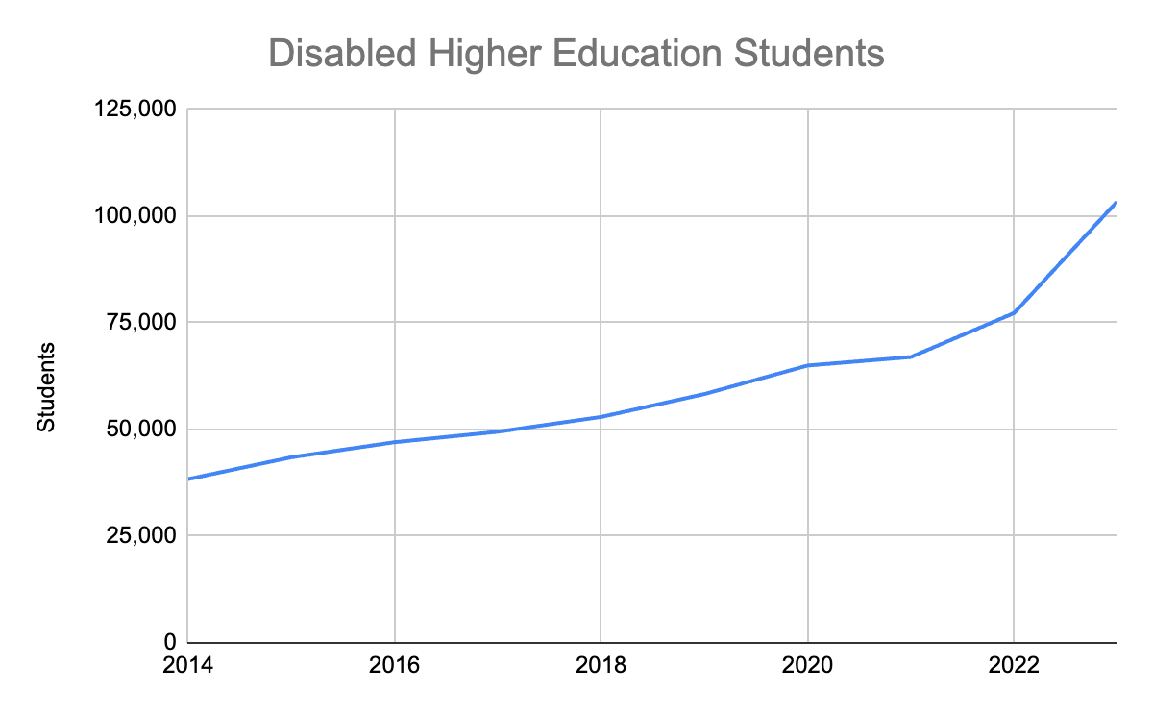

# *Figure 1. Number of Disabled Higher Education Students between 2014 and 2023* [*[13]*](https://paperpile.com/c/zJ6SRg/DCxL)

Following the formation of the Disability Alliance Group and the Union of the Physically Impaired Against Segregation (UPIAS) [[14]](https://paperpile.com/c/zJ6SRg/IhFt), [[15]](https://paperpile.com/c/zJ6SRg/fDuh), disability was redefined in HEI policy in the 1990s. It was no longer seen as a welfare issue but rather in terms of human rights and equality [[15]](https://paperpile.com/c/zJ6SRg/fDuh). This led to the introduction of the Special Educational Needs and Disability Act [[16]](https://paperpile.com/c/zJ6SRg/fAJ9) and the Public Sector Equality Duty in 2001 and 2005 [[17]](https://paperpile.com/c/zJ6SRg/Xy1N). The definition of “disability” within HEI shifted from being a supposed personal problem to recognising disability as disabling due to societal standards. As a result, these policies made educational institutions responsible for removing barriers and ensuring equal access to education for all [[15]](https://paperpile.com/c/zJ6SRg/fDuh).

Failure to meet this legislation can lead to committing unlawful discrimination. If the affected student or their family decide to take legal action, this can result in reputational damage and fines. A poignant example occurred at the University of Bristol in 2018 when a disabled student committed suicide the day before she was due to deliver a presentation [[18]](https://paperpile.com/c/zJ6SRg/A7P2). Despite her requests for reasonable adjustments, such as an alternative assessment method that could have been facilitated through improved digital accessibility, no substantial steps were taken to accommodate her. The student's family pursued legal action against the university, leading the university to pay damages of £50,518 in 2024 [[18]](https://paperpile.com/c/zJ6SRg/A7P2). The fine imposed constituted only 0.006% of the university's total income for that academic year [[19]](https://paperpile.com/c/zJ6SRg/fQhW), underscoring significant disproportionality between the university's financial resources and the penalties for non-compliance even in grave cases. This highlights that legal penalties alone may not suffice in upholding the Equality Act, giving further justification to this research.

Furthermore, despite legislation, students still face several barriers in education. The three key obstacles disabled students experience are “the negative attitudes displayed by faculty members…architectural barriers: inaccessible information and technology” [[7]](https://paperpile.com/c/zJ6SRg/dDdi) p6. Due to these barriers, 26% of disabled students always feel excluded and are the most at risk of dropping out of university [[20]](https://paperpile.com/c/zJ6SRg/IQN4)[[20], [21]](https://paperpile.com/c/zJ6SRg/IQN4+OKm5), [[22]](https://paperpile.com/c/zJ6SRg/16xw). In 2019, 13.2% of disabled students dropped out of university in comparison to 9.7% of non-disabled [[23]](https://paperpile.com/c/zJ6SRg/FbGE). Autistic students, in particular, are more likely to terminate their studies in comparison to any other group, at a rate of 36% [[24]](https://paperpile.com/c/zJ6SRg/dHkf). In 2019, 7,900 Autistic students dropped out of academia, resulting in an estimated £73 million in lost tuition across the country [[24]](https://paperpile.com/c/zJ6SRg/dHkf). This underscores the critical need for universities to proactively address these barriers, including digital accessibility. This will ensure equity in higher education and maintain tuition income.

## The Public Sector Bodies (Websites and Mobile Applications) Accessibility Regulations 2018

In 2018, the UK Government implemented the PSBAR [[25]](https://paperpile.com/c/zJ6SRg/1xBw). This section explores the PSBAR, its implications, and its relevance to this research.

The PSBAR ensures public sector services and content, including websites and mobile apps, are accessible to all audiences, including those who are disabled. Any new digital platforms were required to meet the accessibility regulations by 2019, and pre-existing platforms had till 2020 [[25]](https://paperpile.com/c/zJ6SRg/1xBw). This regulation is relevant, as this research paper investigates university websites that fall under the public sector.

According to the PSBAR, public sector websites and mobile apps must meet international Web Content Accessibility Guidelines (WCAG) 2.2. AA accessibility standards [[26]](https://paperpile.com/c/zJ6SRg/7dpN). The WCAG 2.2. includes 86 success criteria and breaks down into three conformance levels: A, AA, and AAA [[27]](https://paperpile.com/c/zJ6SRg/0v2E).

The Government Digital Services (GDS) monitor public sector websites by testing a sample every year. If a website is found non-compliant, the GDS sends the organisation a letter with issues that need fixed [[28]](https://paperpile.com/c/zJ6SRg/wisJ) and requests a statement within 12 weeks with issues that have or will be fixed, including a timeline, or a disproportionate burden assessment evidence within 7 days [[29]](https://paperpile.com/c/zJ6SRg/6heD). If an organisation fails to engage with the GDS, the Equality and Human Rights Commission (EHRC) sends a letter setting out the scope of its enforcement powers. If the EHRC receives no response, they enter “into a binding agreement to comply with the regulations” or conduct “an investigation into the failure to make reasonable adjustments to ensure website accessibility.” p21 [[29]](https://paperpile.com/c/zJ6SRg/6heD). However, there are no other legal or financial implications from the body. As such, after having two years to ensure website accessibility, only 1.3% of public sector websites met PSBAR, and 20% of organisations never responded to the GDS reports [[3]](https://paperpile.com/c/zJ6SRg/MbYV). The lack of serious consequences for non-compliance suggests that legal frameworks alone are insufficient to drive change in digital accessibility, providing further importance to this research.

## State of Digital Accessibility in HEI

International studies on HEI website accessibility reveal widespread non-compliance, highlighting significant global challenges. In Saudi Arabia, a study involving 58 HEI homepages found that 95% of sites required improvement [[30]](https://paperpile.com/c/zJ6SRg/8gZC). Similarly, Akgul's study across all 179 Turkish universities discovered that only 14 universities met level A compliance [[31]](https://paperpile.com/c/zJ6SRg/BqrX). While it might be hoped that examples of better compliance exist, the overarching evidence from diverse international contexts shows a uniform lack of adherence to WCAG guidelines within the public and private sector. This is supported by WebIAM findings where 95.9% of homepages failed to meet WCAG standards, with an average of 56.8 errors per page [[32]](https://paperpile.com/c/zJ6SRg/p6sB). This consistent pattern suggests that the problem of non-compliance is systemic rather than isolated to specific regions or institutions.

Regional studies on university website accessibility reveal variations in non-compliance, underscoring the influence of geographical and cultural factors. Kane and Shulman evaluated websites from the top 100 internationally ranked universities, finding that institutions in Australia and New Zealand exhibited the highest levels of accessibility. European and North American university websites demonstrated moderate compliance, while websites of Asian universities showed significantly more accessibility errors. Complementing these findings, Shawar's comparative analysis of universities in Jordan, various Arab regions, and the UK identified an error ratio of 13:5:1 [[33]](https://paperpile.com/c/zJ6SRg/mqVh). Rashidi et al. examined ten UK and Iranian university websites and also discovered lower error rates in UK universities but still displaying significant issues [[34]](https://paperpile.com/c/zJ6SRg/BNs7). However, it is important to consider that the apparent deficiencies in digital accessibility in non-English-speaking regions may stem from the limitations of automated translation tools, which often fail to accurately translate critical website components like video captions—a fundamental aspect of WCAG compliance [[35]](https://paperpile.com/c/zJ6SRg/sOfA). This issue was highlighted by Kane and Shulman, who noted an increased propensity for accessibility errors in sites translated to or from Asian languages, likely due to translation challenges [[36]](https://paperpile.com/c/zJ6SRg/BUg0). These findings highlight regional disparities in digital accessibility standards, suggesting that geographical and cultural factors may influence compliance levels.

Focusing on the UK,current research on HEI website accessibility also proves poor conformance. Sitemorse’s quarterly digital accessibility checks on UK HEI institutions reveal that only 12 institutions out of 209 have complied with accessibility standards at least once since January 2014 [[37]](https://paperpile.com/c/zJ6SRg/155T). Alim’s evaluation of 66 UK universities discovered an average of 19 checkpoint violations per university homepage [[38](https://paperpile.com/c/zJ6SRg/6Brg), p.6]. Nonetheless, it is important to note that Alim used the 2021 Complete University Guide when selecting universities, indicating potential sample bias. Universities that have a history of paying for ranking services have an improved ranking of 191 positions, on average [[39]](https://paperpile.com/c/zJ6SRg/4T2h). Chirikov does not specifically name these universities and simply defines them as having used the Complete University Guide advertising services on many occasions. Consequently, this paper assumes the universities that benefit from the improved rankings are older universities, such as Russell Groups, and those with bigger marketing budgets. This evidence supports that rankings are biased [[40]](https://paperpile.com/c/zJ6SRg/fP92) [[41]](https://paperpile.com/c/zJ6SRg/45d9)**.** Together, these studies emphasise the persistent shortcomings despite regulatory pressures among UK universities and the need to investigate more varied institutions in the UK.

## Consequences of Digital Accessibility

This section outlines the key impact and consequences of improved website accessibility, including higher website traffic, engagement, student applications, and tuition revenue.

A key benefit and consequence of digital accessibility for universities is improved search engine optimisation (SEO) and website traffic [[4]](https://paperpile.com/c/zJ6SRg/yi9h) [[5]](https://paperpile.com/c/zJ6SRg/m8x0) [[42]](https://paperpile.com/c/zJ6SRg/uX2Z) [[43]](https://paperpile.com/c/zJ6SRg/DBzK). 93% of prospective students use HEI websites to receive information, and 58% use a search engine to find these when deciding where to apply, underscoring the importance of SEO and competitive website traffic [[44]](https://paperpile.com/c/zJ6SRg/a09b). After improving the accessibility of 847 websites, Accessibility Checker found an increase in SEO and organic traffic amongst all websites, as evidenced by the pie chart below. 66.1% of websites experienced a 101-150% rise in organic website traffic after implementing an accessibility solution, demonstrating the positive implications of accessibility [[45]](https://paperpile.com/c/zJ6SRg/qKiY). This is supported by Al-Kabi's study across 27 Jordanian universities, which demonstrated a positive correlation between website accessibility and increased web traffic [[46]](https://paperpile.com/c/zJ6SRg/dkJe). However, while traffic and SEO can increase a website's visibility, it does not automatically translate into higher engagement. User engagement is influenced by multiple factors, including content relevance, user experience, and interactive features [[47]](https://paperpile.com/c/zJ6SRg/t0VM). This evidence shows that enhancement in traffic and SEO can create opportunities for higher user engagement, although the direct impact on engagement may depend on other factors.

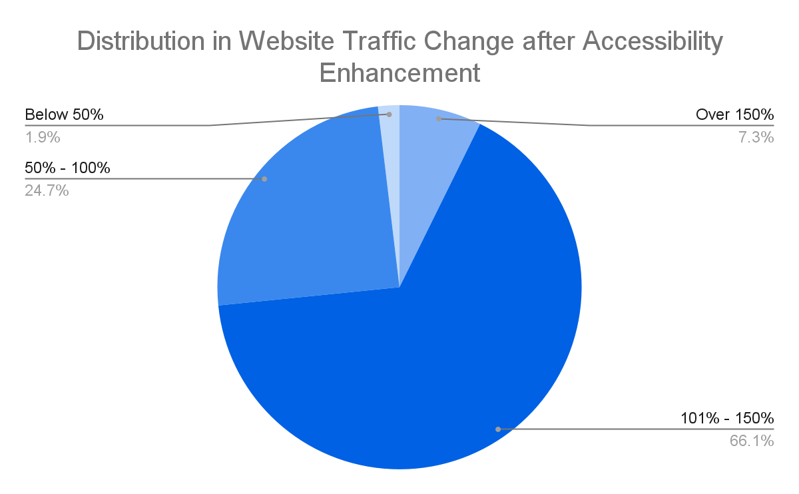

# *Figure 2. Distribution in Website Traffic Change after Accessibility Enhancement*

Studies that directly investigate the relationship between digital accessibility and engagement reveal strong correlations. The Click Away Pound survey found that 70% of disabled people would leave a website if it were difficult to navigate or use, demonstrating the significant impact of website accessibility on engagement [[6]](https://paperpile.com/c/zJ6SRg/RqiC). At the time of the survey, disabled people in the UK had an estimated spending power of £11.75 billion, highlighting the engagement and economic impact of website accessibility [[6], [48]](https://paperpile.com/c/zJ6SRg/RqiC+vKtq).

Internationally, this relationship between accessibility and engagement is confirmed byParajuli and Eika, who interviewed sixteen blind participants about their experience of using Norwegian university websites [[49]](https://paperpile.com/c/zJ6SRg/lZCs). They found that the search form on university websites did not provide relevant results, a clear violation of WCAG level AA [[50]](https://paperpile.com/c/zJ6SRg/9doC). Consequently, users felt frustrated over irrelevant or inadequate search results, leading to high bounce rates. Nevertheless, the study focused on only four universities, may restrict the generalisability of these findings, suggesting a need for more comprehensive research across larger demographics. Collectively, these findings evidence the strong impact of poor accessibility on university website engagement.

Studies investigating the relationship between digital accessibility and engagement across private and public HEI reveal diverse outcomes. A study in Saudi Arabia assessed 29 public and 29 private HEI, showing higher website engagement and accessibility among public universities [[30]](https://paperpile.com/c/zJ6SRg/8gZC). It found that 3% of private universities fully met WCAG standards, in comparison to 13% of public universities. Public university websites experienced more time spent on page, pages per visit, and lower bounce rates. A study comparing digital accessibility in Turkish private versus public university websites found that both largely failed to meet WCAG 2.0 criteria and had similar average bounce rates, with public universities performing better by 2% [[31]](https://paperpile.com/c/zJ6SRg/BqrX). However, 15% of private universities, compared to a mere 0.06% of public universities, had bounce rates exceeding 51%, indicating very poor engagement with private universities. Contrasting findings emerged from a Jordanian study that examined 16 private and 11 public universities [[46]](https://paperpile.com/c/zJ6SRg/dkJe). This study identified no statistically significant differences in digital accessibility, SEO, or engagement between private and public universities, suggesting that other factors may mediate the impact of institutional type on these metrics. While there is evidence of better performance and engagement at public universities in some regions, these studies collectively highlight the complexities underlying the relationship between digital accessibility, institutional type, and engagement.

Website usability, an integral part of website accessibility, has been found to improve university conversion rates, including applications and prospective paying students. When investigating the relationship between these two variables, Mombarg found a significance level of 0.003, indicating a statistically significant correlation [[51]](https://paperpile.com/c/zJ6SRg/JsDo). Additionally, due to the inaccessibility of websites, some students may give up and not apply in the first place, resulting in lost prospective students. When investigating the application process of blind students at the University of Jordan, the researchers discovered that 17% of the application steps were “impossible” for disabled students [[52]](https://paperpile.com/c/zJ6SRg/4Bw5). One of the “impossible” tasks was reading information about specific courses, including taught content; a key deciding factor when applying to universities [[53]](https://paperpile.com/c/zJ6SRg/O6Ph). As these students did not have sufficient information about the courses, they did not apply. However, Briggs finds that students’ decision factors differ depending on their selected course [[54]](https://paperpile.com/c/zJ6SRg/Wkaa). When surveying 650 students on their university choice, she found that engineering students scored “research reputation” marginally higher than “information supplied by university”, which includes information about taught content. Engineering is frequently listed as one of the hardest courses to successfully receive an offer for and complete [[55]](https://paperpile.com/c/zJ6SRg/d4LA) [[56]](https://paperpile.com/c/zJ6SRg/6A52) and has a high average entry requirement of up to A*AB at A-Levels [[57]](https://paperpile.com/c/zJ6SRg/Sb0i). This indicates that students who have higher intelligence or have a specific competitive course in mind may be less impacted by the accessibility and ease of the application process. This entry barrier emphasises the urgent need for universities to improve their digital interfaces to ensure equal access for all and increase their number of received applications, no matter the field of study.

Lastly, an accessible website cuts down on maintenance costs for universities in the long run. An accessible website can save between 12% to 35% of usual maintenance costs [[4]](https://paperpile.com/c/zJ6SRg/yi9h). However, most universities have established and complex websites, which would require re-building. This would be a very costly process, where re-designs of simple websites range around $30,000 [[58]](https://paperpile.com/c/zJ6SRg/piVD). This demonstrates that while initial investments in redesigning websites may be substantial, the long-term savings in maintenance costs provide a compelling financial incentive and a cost-effective solution for universities in the long run.

# Methodology

## Philosophical Approach

The philosophical approach for this research project is positivism. Positivism is an appropriate fit for this research as it relies on empirical observation and objective testing [[59]](https://paperpile.com/c/zJ6SRg/wu1t). This approach supports Research Questions 1, 2, and 4 thanks to its emphasis on measurable data. This will determine current levels of web accessibility and engagement and identify common accessibility violations. Positivism is also equipped to answer Research Question 3, which requires investigating the relationship between variables through statistical analysis. Nonetheless, positivism is limited, as it does not fully capture the complexity of human interactions [[59]](https://paperpile.com/c/zJ6SRg/wu1t). In the context of this study, this includes the experiences of disabled users, including why certain accessibility features impact engagement. This highlights that while positivism effectively underpins the methodology for addressing the research questions, it falls short in capturing the nuanced human experiences of disabled users. This research is limited in its time and resources and will, therefore, only be focusing on statistical analysis. However, this limitation underscores the need for future work to integrate qualitative insights to fully understand the impact of accessibility features on user engagement.

## Methodological Approach

The research method for this project is a quantitative approach. This approach is particularly suited to measure and analyse the relationships and patterns between variables like web accessibility and user engagement on university websites [[59]](https://paperpile.com/c/zJ6SRg/wu1t). Quantitative methods enable the collection of empirical data that can be statistically tested to validate the hypotheses. This method is advantageous over qualitative or mixed methods in this context because it allows for precise, objective, and generalisable results, which are essential for drawing conclusions about the efficacy of web accessibility initiatives across a broad spectrum of universities. However, a quantitative statistical approach is limited by not taking into account the human experience, an integral part of understanding digital accessibility. Nonetheless, this research is limited in its time and resources.

A quantitative approach works well with the positivist philosophical framework adopted in this study. Positivism is rooted in the belief that reality can be captured through observable phenomena and that knowledge is derived from empirical data [[59]](https://paperpile.com/c/zJ6SRg/wu1t). By employing statistical tools and techniques, this methodology directly supports positivism's emphasis on measurable and observable data as a source of scientific knowledge. Through its structured methods, quantitative research can conclusively test theories and hypotheses, such as the impact of improved web accessibility on user engagement, thereby providing empirical support to theoretical assertions made in the field of digital accessibility in higher education.

## Data Science Methodology

### Selecting Universities

Universities will be selected randomly and divided into two groups: Russell Group and ex-polytechnic universities. This selection method will ensure that the research is statistically representative of UK universities, minimises selection bias, and is generalisable. Additionally, dividing the universities into Russell Group and ex-polytechnic recognises their distinct historical, educational, and resource backgrounds. Russell Group universities are traditionally research-intensive and are perceived as more prestigious, often attracting a different student demographic and more funding than ex-polytechnic universities, which were granted university status post-1992 [[60]](https://paperpile.com/c/zJ6SRg/xC4h)**.** This approach helps to explore whether these historical and resource differences translate into variations in digital accessibility and user engagement on their websites. By comparing these two groups, the study aims to uncover systemic disparities or advantages in digital accessibility, which could be influenced by the universities' differing missions, resources, and student bodies.

It is important to note that this research will not include Oxford or Cambridge University in its samples. This exclusion is justified due to their high status, such as regularly ranking in the top universities across the world [[61]](https://paperpile.com/c/zJ6SRg/5QEz), and access to resources, which is not representative of all UK universities. This is further supported by Oxford and Cambridge being the only universities in the UK with annual endowments of over £1 billion. In 2023 Oxford received £8,065,000,000 in endowments [[62]](https://paperpile.com/c/zJ6SRg/hScL) [[63]](https://paperpile.com/c/zJ6SRg/MOe9). After Cambridge, the university with the third most endowments was the University of Edinburgh at £559,000,000 [[64]](https://paperpile.com/c/zJ6SRg/3n60). Including these outliers could potentially lead to conclusions that might not be applicable to the majority of universities that operate under different financial constraints and demographic profiles. By excluding them, the research aims to provide a more accurate reflection of the digital accessibility landscape across the broader spectrum of UK HEI, thus enhancing the generalisability of the findings to a more typical university setting.

### Accessibility Evaluation

Website accessibility can be assessed using automated accessibility tools. Vigo and Brajnik argue that automated tools do not always detect accessibility issues [[65]](https://paperpile.com/c/zJ6SRg/v7ic). However, this can be mitigated by using a combination of automated tools [[66]](https://paperpile.com/c/zJ6SRg/0HPQ). Consequently, this research will use a minimum of two automated tools. When selecting the correct automated accessibility tool the key requirements included price, presentation and analysis of data, and level of WCAG conformance. Given this study’s resource limitations, the tools needed to be free and publicly available. In line with previous research [[67]](https://paperpile.com/c/zJ6SRg/XUrZ)[[30], [46]](https://paperpile.com/c/zJ6SRg/8gZC+dkJe) [[36]](https://paperpile.com/c/zJ6SRg/BUg0), and given these requirements, this study selects WAVE [[68]](https://paperpile.com/c/zJ6SRg/kWgZ) and AChecker [[69]](https://paperpile.com/c/zJ6SRg/iM2I). These tools check conformity with level A and AA and output in-depth data on accessibility violations in terms of WCAG criteria, rather than a simple “pass” or “fail”.

WCAG conformance is categorised into “perceivable, operable, understandable, and robust.” Perceivable accessibility ensures digital content is available to all the senses, including sight, hearing, and/or touch [[70]](https://paperpile.com/c/zJ6SRg/PUvi). An example of a WCAG level A perceivable check is images having appropriate alternative text. “Focus Not Obscured”, a WCAG 2.2. level AA check, requires that “when elements have keyboard focus, they are not entirely covered or hidden by page content” [[70]](https://paperpile.com/c/zJ6SRg/Y5zX). Examples of understandable WCAG checks include consistent navigation and identifying page language using lang attributes in HTML. Finally, robust digital accessibility states that “content must be robust enough that it can be interpreted reliably by a wide variety of user agents, including assistive technologies” [[70]](https://paperpile.com/c/zJ6SRg/KmdW). Furthermore, to conform to the PSBAR, public sector websites, and mobile apps require an easily available, published accessibility statement explaining their digital accessibility features. The WCAG conformance levels and accessibility statements are important to this literature review, as they provide a well-defined and established framework for analysing and reviewing website accessibility which this paper plans to utilise.

The WAVE tool analyses webpages and then embeds icons and indicators into the page. Red icons symbolise accessibility errors, yellow icons symbolise alerts and possible errors, green icons symbolise accessibility features, blue icons symbolise structural or semantic elements, purple icons symbolise the use of HTML 5 structural elements, and black icons symbolise colour contrast errors [[68], [69]](https://paperpile.com/c/zJ6SRg/iM2I+kWgZ). Thanks to its ease and use of visual elements, WAVE is a time-efficient and interactive tool to identify accessibility problems. AChecker categorises errors into “known”, “likely”, and “potential”. “Known” errors have been clearly identified by the automated tool. “Likely” are recognised errors that are probably accessibility issues but require further human input for a definite conclusion. “Potential” problems need human evaluation, as the tool is unable to determine if the issue is a barrier. Using these established tools together will improve the validity and readability of data and provide statistical insights to answer the research questions.

This study will also conduct manual accessibility statement checks. These statements are publicly available on university websites and are legally required under the PBSAR, as outlined in section 2.2. First, it will be determined if a university has an accessibility statement on their website followed by manually checking the statement. It must include whether the website is “fully” compliant, “partially” compliant, or “not compliant." If it is not “fully” compliant, the statement must list where the website does not meet accessibility standards, where users can seek alternative accessible content, and how to get in touch to report accessibility issues. Universities may have valid reasons for not complying with accessibility standards, such as being “a disproportionate burden to fix” [[25]](https://paperpile.com/c/zJ6SRg/1xBw). In this situation, the accessibility statement must include this. This approach accounts for the limitation of relying on automated tools and identifies discrepancies between reported and actual compliance.

### Engagement Evaluation

Website engagement can also be analysed using publicly available automated tools. In line with previous research, this study will utilise Similarweb [[71]](https://paperpile.com/c/zJ6SRg/NWk4) [[30]](https://paperpile.com/c/zJ6SRg/8gZC). The evaluation of website engagement includes average time on page, pages per session, and bounce rate. Bounce rate is defined as “the percentage of users who leave the site having visited just a single page” [56]. A low bounce rate, therefore, indicating better engagement [[72]](https://paperpile.com/c/zJ6SRg/56Zx). The average bounce rate for all industries is 30.5% [[73]](https://paperpile.com/c/zJ6SRg/lVDM). Additionally, this study will focus only on unique page views, to prevent skewing data with repeated visits from the same users. Similarweb is the ideal tool to analyse website engagement, as it provides all this information over a three-month period. This gives easily-available quantitative insight into user engagement, which is necessary to test hypothesis 2 and answer research questions 1 and 3.

This study complies with the strictest ethical guidelines, guaranteeing that all data used is freely accessible to the public. Additionally, by identifying and sharing best practices on digital accessibility, this research aims to advocate for improvements that promote accessibility and engagement, aligning with social inclusion and educational goals.

### Data Cleaning

To guarantee data integrity and quality, data will be cleaned and normalised before analysis [[30], [74]](https://paperpile.com/c/zJ6SRg/8gZC+vqdj). This will require a number of steps, such as handling missing data and eliminating duplicates. Ensuring the accuracy and dependability of the findings is crucial, as it mitigates errors and inconsistencies that may distort the study. Additionally, data normalisation will be used to ensure that engagement measurements from other universities can be compared. In particular, the total number of visits will be used to normalise page views and time spent on the page. This will account for variations in university size and popularity. This offers a more reliable basis upon which to draw conclusions on how accessibility affects user engagement.

### Analysis

In order to thoroughly analyse the relationship between user engagement and web accessibility in UK universities, this study will employ regression and correlation analyses. These statistical techniques will enable the examination of how website accessibility impacts user engagement metrics like page visits, time on site, and bounce rates. Using these methods, the study seeks to identify trends, patterns, and possible causes in order to provide a thorough grasp of the dynamics at work.

Regression analysis enables the modelling of correlations between a dependent variable (like user engagement metrics) and one or more independent variables (like WCAG compliance levels) [[75]](https://paperpile.com/c/zJ6SRg/RG2I), making it especially well-suited to this research. This analysis will quantify the extent to which accessibility predicts user engagement, controlling for potential confounding variables like university type (Russell Group vs. ex-polytechnic). This is crucial for answering Hypothesis 2, which projects that greater accessibility levels are correlated with higher engagement levels.

Regression analysis will be complemented with correlation analysis, which quantifies the direction and strength of the association between user engagement and accessibility metrics [[75], [76]](https://paperpile.com/c/zJ6SRg/qf9W+RG2I). This approach will provide insights into the extent to which these variables are related in various university settings. This will also be pivotal in exploring the differences between Russell Group and ex-polytechnic universities, answering Research Question 4 and testing Hypothesis 2.

The statistical analysis will be carried out using Weka, a software known for its robust capabilities in data analysis, particularly for machine learning and statistical modelling [[76]](https://paperpile.com/c/zJ6SRg/qf9W). Weka is the perfect option for this study because of its intuitive interface and wide range of data processing capabilities. It facilitates exploratory data analysis, regression modelling, and the visualisation of data through graphs, scatter plots, and heat maps - all necessary for this research. The results from both regression and correlation analyses will be visualised using a combination of bar charts and line graphs to depict trends, along with scatter plots to illustrate the relationships and density distributions between accessibility and engagement metrics. The use of these visualisations is expected to aid the interpretation of complex datasets and improve the presentation of findings, making them accessible to a broader audience, including those in the education sector.

# 

# Analysis

The dataset used in this study was compiled manually, ensuring thorough completeness and accuracy in the process. This process allowed for the immediate identification and resolution of any potential gaps, resulting in a dataset with no missing entries which supports data analysis and machine learning techniques.

# Results and Findings

In this investigation, it has been assumed that the dataset accurately reflects patterns and trends of UK university homepages in terms of accessibility and engagement.

## Engagement

The analysis of web engagement across university homepages revealed an average visit duration of 5 minutes and 7 seconds, with users navigating through an average of 5.3 pages per session, and a 39.8% bounce rate (Table 1).

On average, ex-polytechnic websites had a 26-second longer visit duration, a 5.9% lower bounce rate, and users visited 0.6 more pages. The university with the worst website engagement was the University of Birmingham, with a visit duration of 2 minutes and 15 seconds, 3.4 pages per session, and a 57.6% bounce rate (Appendix A.1., A.2., A.3.).

|  |  |  |  |
| --- | --- | --- | --- |
| University Type | Average Visit Duration (minutes) | Average Number of Pages Visited per Session | Average Bounce Rate |
| All Universities | 05:07 | 5.3 | 39.8 |
| Russell Group Universities | 04:51 | 5 | 43.4 |
| Ex-polytechnic | 05:17 | 5.6 | 37.5 |

# *Table 1. Engagement Levels of Russell Group and Ex-Polytechnic University Websites*

## Accessibility Level

The average number of total WAVE issues per UK university homepage was 40.7, with an average of 3.3 low contrast issues and 3.3 errors per homepage (Table 2). The findings showed no difference in the average number of errors and low contrast issues between university types. However, ex-polytechnic universities had an average of 11 more alerts (Appendix B.1.). A manual investigation would be required to identify if these alerts are actual errors.

|  |  |  |  |  |
| --- | --- | --- | --- | --- |
| University Type | Errors | Low Contrast | Alerts | Total Issues |
| All Universities | 3.3 | 3.3 | 34.1 | 40.7 |
| Russell Group Universities | 3.3 | 3.3 | 27.5 | 34.1 |
| Ex-polytechnic | 3.3 | 3.3 | 38.5 | 40.7 |

# *Table 2. WAVE Accessibility Issues of Russell Group and Ex-Polytechnic University Websites*

Known and likely AChecker problems averaged 13.6 and 0.6, respectively. The average number of potential problems found across all universities was 393.9 per homepage, significantly increasing the average of total issues (Appendix B.2.). “Potential” problems need human evaluation, as AChecker is unable to determine if the issue is an actual barrier.

Russell Group universities and ex-polytechnics had a similar number of likely problems per homepage, of 0.4 and 0.7 respectively. On average, Russell Group universities had 6.4 more known problems and 38.7 more potential problems in comparison to ex-polytechnic universities (Appendix B.3.). This does not align with the findings of WAVE, where Russell Group universities had fewer potential problems (also defined as “alerts”) (Table 3).

|  |  |  |  |  |
| --- | --- | --- | --- | --- |
| University Type | Known Problems | Likely Problems | Potential Problems | Total problems |
| All Universities | 13.6 | 0.6 | 393.9 | 408.1 |
| Russell Group Universities | 17.5 | 0.4 | 417.4 | 435.3 |
| Ex-polytechnic | 11.1 | 0.7 | 378.7 | 390.5 |

# *Table 3. AChecker Accessibility Issues Levels of Russell Group and Ex-Polytechnic University Websites*

## Common Violations

The most common accessibility errors identified by WAVE across UK universities included very low contrast (Appendix C.1.)**.** The most common alerts found by WAVE were redundant title text (Appendix C.2.). This was particularly notable in ex-polytechnic universities, which showed a frequency of 16.7 compared to Russell Group universities with 6.9.

The most frequent known issues found by AChecker in UK universities included misuse of HTML elements such as italic tags. Russell Group universities had an average of 8.1 of these violations in comparison to ex-polytechnics with 3.8 (Appendix C.3.). The most common likely issues were the misuse of p element, with an average of 0.32 violations per Russell Group homepage and 0.57 per ex-polytechnic homepage (Appendix C.4.).

42.7% of known issues found on all university websites by AChecker violated success criteria A (Table 4) (Appendix D.1.). For known issues, Russell Group universities had a lower proportion of criteria A violations (26.5%) compared to criteria AA (73.4%), suggesting a better foundational compliance. All Likely Issues found on university homepages violated criteria A (Appendix D.2.).

|  |  |  |
| --- | --- | --- |
| University Type | Errors for Criteria A (%) | Errors for Criteria AA (%) |
| All Universities | 42.7 | 57.3 |
| Russell Group Universities | 26.5 | 73.5 |
| Ex-polytechnic | 57.4 | 42.6 |

# *Table 4. Criteria A versus AA Accessibility Violations of Russell Group and Ex-Polytechnic University Websites*

## Accessibility Features

Analysis showed that UK university websites displayed an average of 35.2 accessibility features, 73.1 structural elements, and 141.3 ARIA attributes per homepage (Table 5). Both groups displayed a similar commitment to using accessibility features and structural elements (Appendix B.2.). There was a significant difference in the use of ARIA elements, with Russell Group universities averaging 110.2 per homepage, compared to 160.8 for ex-polytechnics.

|  |  |  |  |
| --- | --- | --- | --- |
| University Type | Features | Elements | Aria |
| All Universities | 35.2 | 73.0 | 141.2 |
| Russell Group Universities | 35.1 | 73.7 | 110.2 |
| Ex-polytechnic | 35.3 | 72.7 | 160.8 |

# *Table 5. Accessibility Features of Russell Group and Ex-Polytechnic University Websites*

## Accessibility Statements

Accessibility statements were present on all university websites except the University of Plymouth which wrote 70 words about being “committed to providing a website that is accessible to the widest possible audience". 77.8% of universities listed all the necessary information to comply with Accessibility Statement requirements (Appendix E.1.). The universities that did not meet these requirements usually failed due to not stating where users can seek content in an alternative accessible format.

91.2% of universities declared partial compliance (Table 6), with a 6.9% difference between Russell Group and ex-polytechnic universities (Appendix E.2.). Birmingham City University was the only university stating it is fully compliant with WCAG. Nonetheless, WAVE found 10 accessibility issues and AChecker found 4 known and likely problems, indicating partial compliance.

|  |  |  |  |
| --- | --- | --- | --- |
| University Type | Declared Website Compliance Level (%) | | |
| Not Compliant | Partially Compliant | Fully compliant |
| All Universities | 7.0 | 91.2 | 1.8 |
| Russell Group Universities | 4.5 | 95.5 | 0 |
| Ex-polytechnic | 8.6 | 88.6 | 2.9 |

# *Table 6. Compliance of Website Accessibility Statements of Russell Group and Ex-Polytechnic Universities*

Table 6 demonstrates what percentage of universities declared fixing an accessibility issue is a burden. 63.2% of universities have never claimed a burden. Russell Group universities were 25.2% less likely to have claimed an accessibility issue is a burden to fix compared to ex-polytechnic universities, who attributed this to financial costs (Appendix E.3.).

|  |  |  |  |
| --- | --- | --- | --- |
| University Type | Accessibility Burden Declared (%) | | |
| No Burden | Burden Declared | Unspecified |
| All Universities | 63.2 | 24.6 | 12.3 |
| Russell Group Universities | 86.4 | 9.1 | 4.5 |
| Ex-polytechnic | 48.6 | 34.3 | 17.1 |

# *Table 7. Compliance of Website Accessibility Statements of Russell Group and Ex-Polytechnic Universities*

18.2% of Russell Groups and 22.9% ex-polytechnics did not share when they last conducted an in-depth website accessibility audit (Appendix E.4.). The majority of Russell Group websites (18.2%) were last tested between 2 and 3 years ago. 14.3% of ex-polytechnic websites were also last tested during this time period, and another 14.3% were tested in the last month.

SiteImprove was the most popular subscription-based provider of regular website accessibility tests. 37.1% of ex-polytechnic and 27.3% of Russell Group universities partnered with SiteImprove (Appendix E.5.)**.**

Most university websites (72.7% Russell Group and 65.7% ex-polytechnics) did not state how frequently they test the accessibility of their website (Appendix E.6.). It can be assumed this was because the universities do not pay for a regular automated testing tool or did not want to disclose this information, as it is not legally required. The second most common website testing frequency was weekly, both for Russell Group universities (22.7%) and ex-polytechnics (14.3%).

## Accessibility and Engagement

### Correlation Analysis

The direction and intensity of the relationship between accessibility and website engagement were measured using correlation analysis.

The association between Bounce Rate and Pages per Session (r = -0.78) is one of the most significant observations (Appendix F.1.). It shows that when bounce rate declines, more pages are viewed per session. This relationship is intuitive: consumers are more likely to explore further pages when they do not leave right away.

Visit Duration and Pages per Session had a slight positive correlation with accessibility issues found by WAVE and Achecker, Total Accessibility Features (TAF), and with Statement Compliance. Conversely, Bounce Rate had a slight negative correlation with these variables.

Overall, there is a positive correlation between the accessibility concerns discovered by AChecker (Known and Likely Problems, Total Concerns) and WAVE (Errors, Low Contrast, Total Issues) (Appendix F.1.). This shows that the two accessibility tools are consistent with one another.

### Regression Analysis

Appendix G.1. provides a summary of the regression coefficients and other statistical measures that were produced for each model, including the mean absolute error (MAE), root mean squared error (RMSE), and relative absolute error (RAE).

It is notable that the table contains "NA" values. In linear regression, an attribute is excluded if it does not significantly impact the prediction of the dependent variable; this is represented by a "NA" value in the regression coefficient table. Error (WAVE), Known Achecker Problems, Total Achecker Issues, Statement Compliance, and Last Recorded Test were found to be statistically insignificant predictors of website engagement.

Low Contrast errors (-0.23) and TAF (-10.94) showed a negative correlation with Bounce Rate (Appendix G.1.), suggesting that users are more likely to remain on a website with more accessibility features yet more contrast errors. Additionally, there was a marginally significant association between Likely AChecker Problems (0.05) and Total WAVE Issues (0.09) and Bounce Rate.

Pages per Session had a small positive correlation with Likely Achecker Issues (0.48), but a substantial negative correlation with TAF (WAVE) (-56.86) and Low Contrast (-1.21) (Appendix G.1.). According to this, websites that have more visits per session tend to have less accessibility features and contrast problems, but they may also have a higher likelihood of having AChecker errors. Together, these findings indicate that websites with more Contrast errors and Accessibility Features tend to retain users for longer, however, these users visit less pages.

When predicting Bounce Rate (2.74), the Class variable—which distinguishes Russell Group institutions from ex-polytechnic universities—shows a positive coefficient (Appendix G.1.), suggesting that Russell Group universities might have marginally higher bounce rates than ex-polytechnics. However, the low correlation value (0.19) suggests that this association is relatively modest.

Finally, the models' accuracy and dependability can be inferred from the RMSE and Relative Absolute Error (RAE). For example, the model that predicts Total Issues (AChecker) has one of the highest RMSE values (213.41) (Appendix G.1.), which suggests that its prediction mistakes are more substantial than those of the other models.

# Discussion

## Engagement

Analysing engagement metrics between Russell Group and ex-polytechnic universities reveals interesting contrasts. While ex-polytechnic universities generally exhibited better engagement metrics—such as longer visit durations, lower bounce rates, and more pages per session—these differences were relatively small. This suggests that, while there may be some differences in how users interact with these sites, the type of university (Russell Group vs. ex-polytechnic) may not be the dominant factor influencing user engagement.

## Accessibility

Russell Group and ex-polytechnic universities both displayed comparable accessibility levels. On average, both groups had the same number (3.3) of mistakes and poor contrast problems per homepage, according to WAVE. Ex-polytechnics had significantly more potential issues per homepage. This supports several other studies, which showed that UK university websites display significant accessibility issues [[33]](https://paperpile.com/c/zJ6SRg/mqVh) [[34]](https://paperpile.com/c/zJ6SRg/BNs7) [[37]](https://paperpile.com/c/zJ6SRg/155T). Most notably, in a 2021 paper, Alim found an average of 19 violations per homepage using WAVE [[38]](https://paperpile.com/c/zJ6SRg/6Brg). Using the same tool, this study discovered an average of 40 violations per homepage, indicating an increase in accessibility issues in UK HEI websites.

## Common Violations

The study's examination of common violations revealed that the most common accessibility fault across all universities was very low contrast, which aligns with historical findings when auditing UK HEI websites [[38]](https://paperpile.com/c/zJ6SRg/6Brg) [[67]](https://paperpile.com/c/zJ6SRg/XUrZ) and investigating international university website accessibility [[36]](https://paperpile.com/c/zJ6SRg/BUg0). This implies that universities frequently struggle to ensure adequate contrast, most likely due to design decisions that put aesthetics above functionality.

Russell Group universities were more likely to have form-label issues; problems like empty links and spacer pictures with no alt text were most common among ex-polytechnics. These results broaden the research findings of Alim [[38]](https://paperpile.com/c/zJ6SRg/6Brg), by highlighting particular accessibility issues on which different types of universities can concentrate their efforts. The frequency of these problems suggests that, despite laws being in place, there are still significant gaps in how universities apply accessible design principles and a lack of incentive to do so - a global issue highlighted in studies across various regions [[32]](https://paperpile.com/c/zJ6SRg/p6sB).

Furthermore, 42.7% of accessibility issues identified on university websites in the UK did not meet the requirements of WCAG Level A, the lowest possible standard for web accessibility compliance. This is consistent with WebIAM’s results, which show widespread compliance with fundamental accessibility standards [[32]](https://paperpile.com/c/zJ6SRg/p6sB).

Accessibility Statements

## Accessibility Statements

Compared to ex-polytechnic universities, only 3.4% more of Russell Group universities met the requirements of the Accessibility Statement, indicating that both groups are comparatively aligned in this regard, albeit with space for improvement. Statements lacked specific information about testing frequencies and alternate forms, suggesting that universities may not fully understand the standards or be reluctant to provide complete compliance data. This is particularly concerning, as non-compliance has personal and legal ramifications, as the University of Bristol case [[18]](https://paperpile.com/c/zJ6SRg/A7P2) in the literature review illustrates.

Only one university claimed complete compliance with accessibility criteria, while a sizable number of universities (91.2%) reported only partial compliance. This is consistent with several studies that show widespread challenges in achieving compliance in higher education in the UK [[33]](https://paperpile.com/c/zJ6SRg/mqVh) [[34]](https://paperpile.com/c/zJ6SRg/BNs7) [[37]](https://paperpile.com/c/zJ6SRg/155T).

Connecting these findings to the literature review highlights an important gap; there were no prior studies that investigated website accessibility by using automated tools and checking accessibility statements. This study addresses this gap, emphasising the importance of following accessible guidelines and maintaining transparency, as highlighted by the PBSAR and WCAG standards [[70]](https://paperpile.com/c/zJ6SRg/Y5zX). By including accessibility statements, this research also revealed universities that make the false claim of being fully compliant—like Birmingham City University. As a result, this study makes a significant contribution to the literature by highlighting the necessity for institutions to not only adhere to technological accessibility standards but also to provide users with clear and thorough information about their inclusion practices.

Most universities claiming a burden were historically polytechnic and blamed accessibility issues being a burden on limited financial resources. While no other previous studies investigated the website accessibility of Russell Group and ex-polytechnic universities, Alhadreti explored private versus public universities, which are somewhat comparable in their financial resources and access to investment. Alhadreti found that more public universities fully complied with WCAG than private universities due to investing more in accessibility [[30]](https://paperpile.com/c/zJ6SRg/8gZC). This does not align with this study’s findings, where ex-polytechnic universities (which have less available financial resources) are more likely to claim financial burdens. These results highlight that assistance is required to help universities achieve accessibility standards. This might include financial incentives, technical support, or stricter enforcement of already-existing laws.

## Correlation and Regression Analysis

Accessibility problems found by WAVE and AChecker consistently correlated, reinforcing the reliability and benefits of using a combination of tools, as recommended by Vigo and Harper [[66]](https://paperpile.com/c/zJ6SRg/0HPQ). Nonetheless, the analysis also discovered that Russell Group institutions had greater rates of recognised issues, according to AChecker, even if they typically had fewer Total WAVE Issues. This disparity implies that a multi-tool approach is required for a thorough accessibility assessment. It draws attention to a potential gap in how various tools evaluate accessibility, highlighting a gap in the literature and potential for future research.

With all correlation coefficients between accessibility and engagement being less than 0.2, the results indicate that, although a relationship exists, it is not as substantial as hypothesised. More accessibility features, for example, marginally lower the bounce rate, according to the correlation between TAF and Bounce Rate (-0.2). However, regression analysis found a very strong relationship between Bounce Rate and TAF (-10.9). This is consistent with previous research demonstrating that low accessibility is associated with high bounce rates, including the Click Away Pound survey [[6]](https://paperpile.com/c/zJ6SRg/RqiC). This data supports the idea that accessibility is essential to lower bounce rates and improved user retention [[30]](https://paperpile.com/c/zJ6SRg/8gZC) [[50]](https://paperpile.com/c/zJ6SRg/9doC). However, it highlights that other factors may also impact user engagement, as supported by Kabi, who found no statistically significant relationship between accessibility and engagement [[46]](https://paperpile.com/c/zJ6SRg/dkJe)**.**

Other statistically significant findings discovered using regression analysis included the very strong negative relationship between Pages per Session, the number of Low Contrast errors (-1.21), and TAF (-56.86). Interestingly, there was a strong positive correlation between Pages per Session and institutions' Main Testing Tool for routine audit tests. The number of pages viewed during a session suggests that using particular testing tools—which may be more effective—correlates with increased user engagement. This finding points to a gap in the research, as previous studies explored in the literature review did not investigate the main testing tools used by universities. Further research is needed to examine the efficacy of various accessibility testing tools and their influence on user engagement.

Regression analysis also found a lack of relationships between engagement metrics and accessibility issues. With the selective nature of linear regression models, most attributes did not significantly contribute to the prediction of the dependent variable. This is demonstrated by the presence of "NA" values in the regression table. This suggests that not all engagement indicators or accessibility issues are equally significant across models. For example, none of the engagement models considered Known AChecker Problems, Statement Compliance, and WAVE Errors significant predictors, supporting that other factors may have a greater impact on user engagement [[46]](https://paperpile.com/c/zJ6SRg/dkJe).

Lastly, the RMSE and RAE values reveal the overall performance of the regression models and offer insight into their accuracy when predicting website engagement. One of the highest RMSE values was found in the Total Issues (AChecker) model, indicating that the model could not fully explain a significant amount of the data's volatility. However, most RMSE and RAE values were relatively high. This illustrates the difficulty when forecasting user engagement using accessibility measures alone and highlights the possibility that other factors may be involved.

Overall, this study has identified a number of research gaps in the area of university website accessibility and user engagement. Firstly, this study has filled a research gap by uncovering differences between reported and real compliance with accessibility claims. The paper also emphasises the need for greater research into the efficacy of different accessibility testing methods. Lastly, the weak correlations found between engagement measures and accessibility imply that there is a need for more thorough research on all factors that impact user engagement, including accessibility, and how they work together.

# Conclusion

This study aimed to examine user engagement and web accessibility of UK university homepages, with a focus on Russell Group and ex-polytechnic universities. It employed a quantitative method, utilising SimilarWeb for user engagement metrics and automated accessibility testing tools (WAVE and AChecker). A manual examination of accessibility declarations was also incorporated to evaluate compliance with the PSBAR.

## RQs

### RQ1: What is the current accessibility and engagement level of UK university homepages and the differences between Russell Group versus ex-polytechnic universities, if any?

The average number of WAVE issues and AChecker issues per homepage was 408.1, indicating an overall shortcoming in the accessibility of UK university homepages. Russell Group and ex-polytechnic universities' engagement levels differed slightly, with the former exhibiting marginally higher engagement metrics. All institutions combined had a 39.8% bounce rate and an average visit time of 5 minutes and 7 seconds, indicating a moderate overall engagement level.

### RQ2: What are the most common web accessibility violations on UK university homepages?

WAVE found that the most common web accessibility violations included low contrast and redundant form labels. AChecker highlighted problems with ARIA attributes and the improper use of HTML components. Notably, 42.7% of Known Issues did not fulfil the requirements of WCAG Level A, suggesting that many universities have difficulty achieving even the most basic accessibility standards.

### RQ3: Is there a relationship between the website accessibility of UK universities and their engagement?

Although a relationship between website accessibility and engagement exists, it is not as strong as expected. In general, correlation coefficients between engagement and accessibility were less than 0.2, indicating a very weak relationship and most attributes were deemed statistically insignificant when conducting regression analysis. However, regression analysis did show some stronger correlations, such as those between Bounce Rate and TAF, which is consistent with other studies' findings that higher accessibility can lower bounce rates. The results indicate that although accessibility is important, several other factors may impact user engagement.

## Limitations and Further Research

This research is limited by only using automated accessibility testing techniques, which, although helpful, cannot fully capture the range of accessibility problems that a manual review or user testing may uncover.

Additionally, other factors, such as bounce rate and pages per session, influence the engagement metrics used, such as content quality. This makes it challenging to separate the effect of accessibility alone on user engagement.

Another limitation of the study is that it only examines two categories of universities: Russell Group and ex-polytechnic. This restricts the findings' generalisability to other UK universities. Future studies should broaden the focus to include all UK universities. This would offer a more thorough overview of website accessibility in the UK's higher education sector.

Lastly, there were numerous issues with this study's use of WEKA, an outdated programme that presented substantial difficulties for data processing. Because WEKA's settings were inconsistent, it was challenging to have a simplified workflow. It was also not possible to run WEKA directly on an Apple device, which frequently have problems with external software compatibility. As a result, this study used a remote Microsoft desktop to access the software.

Nevertheless, WEKA could not identify the dataset even with the remote desktop. To resolve this, it was necessary to open the file in LibreOffice, re-save it as a CSV file, and then use WEKA's ArffViewer to convert it to an attribute-relation file format. Working in a virtual environment comes with inherent delay and glitches, and with these additional steps, it significantly slowed down the study.

In future research, more advanced and user-friendly software is recommended to save time on data preparation and enable more efficient and productive analytical procedures.

Future research should also consider using a mixed approach consisting of quantitative analysis and interviews or surveys. This would provide important insights into people's real-life experiences and a better grasp of how digital accessibility affects user engagement in the real world. This mixed-methods approach would ultimately lead to more successful solutions for enhancing web accessibility in higher education.

# 

# Reference List

[1] UK Government. [(2012, Jan.13), *Disability rights*, GOV.UK. [Online]. Available:](http://paperpile.com/b/zJ6SRg/gDUW) <https://www.gov.uk/rights-disabled-person/education-rights>[. [Accessed: 23 Jun. 2024].](http://paperpile.com/b/zJ6SRg/gDUW)

[2] UK Government. [*What are reasonable adjustments and how do they help disabled pupils at school?*, GOV.UK. [Online]. Available:](http://paperpile.com/b/zJ6SRg/2XH2) <https://educationhub.blog.gov.uk/2023/04/10/what-are-reasonable-adjustments-and-how-do-they-help-disabled-pupils-at-school/>[. [Accessed: 23 Jun. 2024].](http://paperpile.com/b/zJ6SRg/2XH2)

[3] UK Government. [*Accessibility monitoring of public sector websites and mobile apps 2020-2021*, GOV.UK. [Online]. Available:](http://paperpile.com/b/zJ6SRg/MbYV) <https://www.gov.uk/government/publications/accessibility-monitoring-of-public-sector-websites-and-mobile-apps-2020-2021/accessibility-monitoring-of-public-sector-websites-and-mobile-apps-2020-2021>[. [Accessed: 23 Jun. 2024].](http://paperpile.com/b/zJ6SRg/MbYV)

[4] [R. Hartjes and C. Strauss, ‘Analyzing Effects of Web Accessibility – A Framework to Determine Changes in Website Traffic and Success’, *Computers Helping People with Special Needs*, pp. 449–455, 2010.](http://paperpile.com/b/zJ6SRg/yi9h)

[5] [T. Kärpänen, ‘How to Ensure Web Accessibility in Digital Services to Improve the Competitive Advantage of an Organization’, *Universal Access in Human-Computer Interaction*, pp. 74–87, 2023.](http://paperpile.com/b/zJ6SRg/m8x0)

[6] S. Borrow, (2016, March), [*Click-Away Pound - Emerging Findings*. Click-Away Pound [Online]. Available:](http://paperpile.com/b/zJ6SRg/vKtq) <http://www.clickawaypound.com/marchinterim.html>[. [Accessed: 23 Jun. 2024].](http://paperpile.com/b/zJ6SRg/vKtq)

[7] [A. Moriña, ‘Inclusive education in higher education: challenges and opportunities’, *Eur. J. Spec. Needs Educ.*, Jan. 2017[Online]. Available](http://paperpile.com/b/zJ6SRg/dDdi): <https://www.tandfonline.com/doi/abs/10.1080/08856257.2016.1254964> [[Accessed: 22June2024].](http://paperpile.com/b/zJ6SRg/dDdi)

[8] [G. Koutsouris et al., ‘A critical exploration of inclusion policies of elite UK universities’, *Br. Educ. Res. J.*, vol. 48, no. 5, pp. 878–895, Oct. 2022.](http://paperpile.com/b/zJ6SRg/ucrM)

[9] A. Shaw., ‘Inclusion of disabled Higher Education students: why are we not there yet?’, *International Journal of Inclusive Education*, vol. 28, no. 6, pp. 820-838, Aug. 2021. [Online] Available: <https://doi.org/10.1080/13603116.2021.1968514>[. [Accessed: 22 Jun. 2024].](http://paperpile.com/b/zJ6SRg/4IFo)

[10] UK Government. [*Definition of disability under the Equality Act 2010*, GOV.UK. [Online]. Available:](http://paperpile.com/b/zJ6SRg/mQ0b) <https://www.gov.uk/definition-of-disability-under-equality-act-2010>[. [Accessed: 22 Jun. 2024].](http://paperpile.com/b/zJ6SRg/mQ0b)

[11] [L. W. F. Bio and R. L. F. Bio, *Students with Disabilities in Higher Education: Facts and Statistics*, BestColleges.com. [Online]. Available:](http://paperpile.com/b/zJ6SRg/acQI) <https://www.bestcolleges.com/research/students-with-disabilities-higher-education-statistics/>[. [Accessed: 22 Jun. 2024].](http://paperpile.com/b/zJ6SRg/acQI)

[12] [N. Kikabhai, *The Rhetoric of Widening Participation in Higher Education and its Impact*. Springer International Publishing.](http://paperpile.com/b/zJ6SRg/UyFK)

[13] UCAS. [(2023, November. 28), *UCAS Undergraduate end of cycle data resources 2023*, ucas.com. [Online]. Available:](http://paperpile.com/b/zJ6SRg/DCxL) <https://www.ucas.com/data-and-analysis/undergraduate-statistics-and-reports/ucas-undergraduate-end-cycle-data-resources-2023>[. [Accessed: 23 Jun. 2024].](http://paperpile.com/b/zJ6SRg/DCxL)

[14] National Disability Arts Collection & Archive. [*Fundamental Principles of Disability*](http://paperpile.com/b/zJ6SRg/IhFt)[, the-ndaca.org. [Online]. Available:](,%20the-ndaca.org.%20%5bOnline%5d.%20Available:%20) <https://the-ndaca.org/resources/audio-described-gallery/fundamental-principles-of-disability/>[. [Accessed: 23 Jun. 2024].](http://paperpile.com/b/zJ6SRg/IhFt)

[15] [A. Shaw, ‘Inclusion of disabled Higher Education students: why are we not there yet?’, *Int. J. Incl. Educ.*, vol. 28, no. 6, pp. 820–838, May 2024.](http://paperpile.com/b/zJ6SRg/fDuh)

[16] [E. Participation, ‘Special Educational Needs and Disability Act 2001’[Online]. Available](http://paperpile.com/b/zJ6SRg/fAJ9)<https://www.legislation.gov.uk/ukpga/2001/10/contents> [[Accessed: 23 Jun. 2024].](http://paperpile.com/b/zJ6SRg/fAJ9)

[17] UK Parliament. *Chapter 8: The Public Sector Equality Duty*. [[Online]. Available:](http://paperpile.com/b/zJ6SRg/Xy1N) <https://publications.parliament.uk/pa/ld201516/ldselect/ldeqact/117/11711.htm>[.](http://paperpile.com/b/zJ6SRg/Xy1N) [Accessed: 23 Jun. 2024].

[18] [DPG Law. *High Court Dismisses University of Bristol’s Appeal in Natasha Abrahart Case*, dpglaw.co.uk. [Online]. Available:](http://paperpile.com/b/zJ6SRg/A7P2) <https://dpglaw.co.uk/high-court-dismisses-university-of-bristols-appeal-in-natasha-abrahart-case/>[. [Accessed: 23 Jun. 2024].](http://paperpile.com/b/zJ6SRg/A7P2)

[19] [R. Kerse, *Our Annual Report and Financial Statements for 2021/22 and our outlook for 2023*. [Online]. Available:](http://paperpile.com/b/zJ6SRg/fQhW) <https://executive-team.blogs.bristol.ac.uk/2022/11/24/our-annual-report-and-financial-statements-for-2021-22-and-our-outlook-for-2023/>[. [Accessed: 23 Jun. 2024].](http://paperpile.com/b/zJ6SRg/fQhW)

[20] Office for Students. (2021, Mar. 11). *Access and participation resources. Findings from the data: sector summary.* officeforstudents.org.uk.[[Online]. Available:](http://paperpile.com/b/zJ6SRg/IQN4) <https://www.officeforstudents.org.uk/media/4dcf0f63-4ff0-4df2-ba52-3b2ef0a8a28d/access-and-participation-data-resources-sector-summary-2021.pdf>[. [Accessed: 23 Jun. 2024].](http://paperpile.com/b/zJ6SRg/IQN4)

[21] NESET. [(2019, Jun. 25), *Drop-Out and Completion in Higher Education in Europe Among Students from Under-Represented Groups*. nesetweb.eu. [Online]. Available:](http://paperpile.com/b/zJ6SRg/OKm5) <https://nesetweb.eu/en/resources/library/drop-out-and-completion-in-higher-education-in-europe-among-students-from-under-represented-groups/>[. [Accessed: 23 Jun. 2024].](http://paperpile.com/b/zJ6SRg/OKm5)

[22] [C. Meehan and K. Howells, ‘In search of the feeling of “belonging” in higher education: undergraduate students transition into higher education’, *Journal of Further and Higher Education*, Nov. 2019[Online]. Available](http://paperpile.com/b/zJ6SRg/16xw)<https://www.tandfonline.com/doi/abs/10.1080/0309877X.2018.1490702>[[Accessed: 23 Jun. 2024].](http://paperpile.com/b/zJ6SRg/16xw)

[23] [H. Sampayo, (2019, November.18), *Disabled British students drop out through lack of support*. [Online]. Available:](http://paperpile.com/b/zJ6SRg/FbGE) <https://gslglobal.com/2019/11/18/disabled-british-students-drop-out-through-lack-of-support/>[. [Accessed: 23 Jun. 2024].](http://paperpile.com/b/zJ6SRg/FbGE)

[24] North East Autism Society. [*Autistic students most likely to drop out of university: investigation*, North East Autism Society. ne-as.org. [Online]. Available:](http://paperpile.com/b/zJ6SRg/dHkf) <https://www.ne-as.org.uk/news/autistic-students-most-likely-to-drop-out-of-university-investigation>[. [Accessed: 23 Jun. 2024].](http://paperpile.com/b/zJ6SRg/dHkf)

[25] [*Understanding accessibility requirements for public sector bodies*, GOV.UK. [Online]. Available:](http://paperpile.com/b/zJ6SRg/1xBw) <https://www.gov.uk/guidance/accessibility-requirements-for-public-sector-websites-and-apps>[. [Accessed: 23 Jun. 2024].](http://paperpile.com/b/zJ6SRg/1xBw)

[26] UK Government. [*Understanding WCAG 2.2*](http://paperpile.com/b/zJ6SRg/7dpN)[.](.%20gov.uk%20%5bOnline%5d.%20Available:%20) GOV. UK. [Online]. Available: <https://www.gov.uk/service-manual/helping-people-to-use-your-service/understanding-wcag>[. [Accessed: 23 Jun. 2024].](http://paperpile.com/b/zJ6SRg/7dpN)

[27] [Level Access. (2023, October. 5). *WCAG 2.2 AA: Summary and Checklist for Website Owners*. levelaccess.com. [Online]. Available:](http://paperpile.com/b/zJ6SRg/0v2E) <https://www.levelaccess.com/blog/wcag-2-2-aa-summary-and-checklist-for-website-owners/>[. [Accessed: 23 Jun. 2024].](http://paperpile.com/b/zJ6SRg/0v2E)

[28] [G. Rhodes. (2022, October. 6). *PSBAR Monitoring and Enforcement Process*. Make Things Accessible. [Online]. Available:](http://paperpile.com/b/zJ6SRg/wisJ) <https://www.makethingsaccessible.com/guides/psbar-monitoring-and-enforcement-process/>[. [Accessed: 23 Jun. 2024].](http://paperpile.com/b/zJ6SRg/wisJ)

[29] UK Government. [*Public sector website and mobile application accessibility monitoring*, GOV.UK. [Online]. Available:](http://paperpile.com/b/zJ6SRg/6heD) <https://www.gov.uk/guidance/public-sector-website-and-mobile-application-accessibility-monitoring>[. [Accessed: 23 Jun. 2024].](http://paperpile.com/b/zJ6SRg/6heD)

[30] [O. Alhadreti, ‘Accessibility, performance and engagement evaluation of Saudi higher education websites: a comparative study of state and private institutions’, *Univers. Access Inf. Soc.*, Feb. 2023](http://paperpile.com/b/zJ6SRg/8gZC).

[31] [Y. Akgül, ‘Accessibility, usability, quality performance, and readability evaluation of university websites of Turkey: a comparative study of state and private universities’, *Univers. Access Inf. Soc.*, vol. 20, no. 1, pp. 157–170, Mar. 2021.](http://paperpile.com/b/zJ6SRg/BqrX)

[32] [A. Parker, (May. 31, 2024), ‘Important Accessibility Statistics to Know’, Acquia. [Online]. Available](http://paperpile.com/b/zJ6SRg/p6sB)<https://www.acquia.com/blog/accessibility-statistics>. [[Accessed: 23 Jun. 2024].](http://paperpile.com/b/zJ6SRg/p6sB)

[33] [B. A. Shawar, ‘Evaluating Web Accessibility of Educational Websites’, *Int. J. Emerg. Technol. Learn.*, vol. 10, no. 4, pp. 4–10, Sep. 2015.](http://paperpile.com/b/zJ6SRg/mqVh)

[34] A. Doulani, [‘Analysis of Iranian and British university websites by world wide web consortium’, *Journal of Scientometric Research*, vol. 2., no. 1, pp. 74-79 [Online]. Available](http://paperpile.com/b/zJ6SRg/BNs7): <https://jscires.org/article/47>. [[Accessed: 23 Jun. 2024].](http://paperpile.com/b/zJ6SRg/BNs7)

[35] WebAIM. [*WebAIM’s WCAG 2 Checklist*. webaim.org. [Online]. Available:](http://paperpile.com/b/zJ6SRg/sOfA) <https://webaim.org/standards/wcag/checklist>[. [Accessed: 23 Jun. 2024].](http://paperpile.com/b/zJ6SRg/sOfA)

[36] [S. K. Kane et al., ‘A web accessibility report card for top international university web sites’, in *Proceedings of the 2007 international cross-disciplinary conference on Web accessibility (W4A) - W4A ’07*, Banff, Canada, 2007[Online]. Available](http://paperpile.com/b/zJ6SRg/BUg0): <http://portal.acm.org/citation.cfm?doid=1243441.1243472>[.](http://paperpile.com/b/zJ6SRg/BUg0) [[Accessed: 23 Jun. 2024].](http://paperpile.com/b/zJ6SRg/sOfA)

[37] [Sitemorse. *2024 Q1/UK & IE Universities.* Sitemorse.com [Online]. Available:](http://paperpile.com/b/zJ6SRg/155T) <https://sitemorse.com/index/report-table.html?rt=2138>[. [Accessed: 23 Jun. 2024].](http://paperpile.com/b/zJ6SRg/155T)

[38] [S. Alim, ‘Web Accessibility of the Top Research-Intensive Universities in the UK’, *SAGE Open*, Nov. 2021[Online]. Available](http://paperpile.com/b/zJ6SRg/6Brg)<https://journals.sagepub.com/doi/10.1177/21582440211056614>. [[Accessed: 23 Jun. 2024].](http://paperpile.com/b/zJ6SRg/6Brg)

[39] [I. Chirikov, ‘Does conflict of interest distort global university rankings?’, *Higher Education*, vol. 86, no. 4, pp. 791–808, Oct. 2022.](http://paperpile.com/b/zJ6SRg/4T2h)

[40] J. Brankovic. “The Absurdity of University Rankings”. 22 March 2021. [Blog entry]. *London School of Economics Blog.* [Available:](http://paperpile.com/b/zJ6SRg/fP92) <https://blogs.lse.ac.uk/impactofsocialsciences/2021/03/22/the-absurdity-of-university-rankings/>[.](http://paperpile.com/b/zJ6SRg/fP92) [[Accessed: 23 Jun. 2024].](http://paperpile.com/b/zJ6SRg/sOfA)

[41] [A. Chatelier, (Nov. 06, 2022), ‘Are University Rankings Biased (2022)?’, Boost. [Online]. Available](http://paperpile.com/b/zJ6SRg/45d9)<https://www.boostcvcl.com/post/are-university-rankings-biased>. [[Accessed: 23 Jun. 2024].](http://paperpile.com/b/zJ6SRg/sOfA)

[42] [*The impact of website accessibility on conversion rates*. [Online]. Available:](http://paperpile.com/b/zJ6SRg/uX2Z) <https://abmatic.ai/blog/impact-of-website-accessibility-on-conversion-rates>[. [Accessed: 23 Jun. 2024].](http://paperpile.com/b/zJ6SRg/uX2Z)

[43] [S. Cao and E. Loiacono, ‘The state of the awareness of web accessibility guidelines of student website and app developers’, in *Social Computing and Social Media. Design, Human Behavior and Analytics*, Cham: Springer International Publishing, 2019, pp. 32–42.](http://paperpile.com/b/zJ6SRg/DBzK)

[44] Modern Campus. [*2023 RNL e-Expectations Trends Report- Attracting, Engaging and Enrolling High School Students*. resources.modercampums.com [Online]. Available:](http://paperpile.com/b/zJ6SRg/a09b) <https://resources.moderncampus.com/2023-e-expectations-trends-report-attracting-engaging-and-enrolling-high-school-students-rnl?pk_vid=61d8b5e583e2de561698850841a6a161>[. [Accessed: 23 Jun. 2024].](http://paperpile.com/b/zJ6SRg/a09b)

[45] [A. Tait, (2023, Jan. 25), *Does web accessibility have a positive impact on SEO?*, Accessibility Checker. [Online]. Available:](http://paperpile.com/b/zJ6SRg/qKiY) <https://www.accessibilitychecker.org/guides/accessibility-seo-impact-study/>[. [Accessed: 23 Jun. 2024].](http://paperpile.com/b/zJ6SRg/qKiY)

[46] [M. N. A. Kabi, ‘Exploring the relationships between web accessibility, web traffic, and university rankings: a case study of Jordanian universities’, *Int. J. High Perform. Comput. Networking*, vol. 12, no. 3, p. 235, 2018.](http://paperpile.com/b/zJ6SRg/dkJe)

[47] [C. Dearing, *Key factors that influence user engagement – Headline Bulletin*. [Online]. Available:](http://paperpile.com/b/zJ6SRg/t0VM) <https://hbuk.co.uk/user-engagement-strategy>[. [Accessed: 23 Jun. 2024].](http://paperpile.com/b/zJ6SRg/t0VM)

[48] S. Borrow, (2016, March), [*Click-Away Pound - Emerging Findings*. Click-Away Pound [Online]. Available:](http://paperpile.com/b/zJ6SRg/vKtq) <http://www.clickawaypound.com/marchinterim.html>[. [Accessed: 23 Jun. 2024].](http://paperpile.com/b/zJ6SRg/vKtq)

[49] [P. Parajuli and E. Eika, ‘A Comparative Study of Accessibility and Usability of Norwegian University Websites for Screen Reader Users Based on User Experience and Automated Assessment’, *Universal Access in Human-Computer Interaction. Design Approaches and Supporting Technologies*, pp. 300–310, 2020.](http://paperpile.com/b/zJ6SRg/lZCs)

[50] WebAIM. [*WebAIM’s WCAG 2 Checklist*](http://paperpile.com/b/zJ6SRg/9doC)[. Webaim.org. [Online]. Available:](.%20Webaim.org.%20%5bOnline%5d.%20Available:%20) <https://webaim.org/standards/wcag/checklist>[. [Accessed: 23 Jun. 2024].](http://paperpile.com/b/zJ6SRg/9doC)

[51] J. Mombarg, “USABILITY AND USER EXPERIENCE DESIGN ANALYSIS ON A UNIVERSITY WEBSITE,” University of Twente, [[Online]. Available:](http://paperpile.com/b/zJ6SRg/JsDo) <https://essay.utwente.nl/85946/1/Mombarg_MA_BMS.pdf>[. [Accessed: 23 Jun. 2024].](http://paperpile.com/b/zJ6SRg/JsDo)

[52] [I. Abu Doush, ‘Evaluating the Web Accessibility of University Online Registration System: case study Jordan’, 2019 [Online]. Available](http://paperpile.com/b/zJ6SRg/4Bw5)<https://dspace.auk.edu.kw/handle/11675/5735>. [[Accessed: 23 Jun. 2024].](http://paperpile.com/b/zJ6SRg/4Bw5)

[53] [D. Heathcote et al., ‘Factors Affecting University Choice Behaviour in the UK Higher Education’, *Education Sciences*, vol. 10, no. 8, p. 199, Aug. 2020.](http://paperpile.com/b/zJ6SRg/O6Ph)

[54] [S. Briggs, ‘An exploratory study of the factors influencing undergraduate student choice: the case of higher education in Scotland’, *Studies in Higher Education*, Dec. 2006 [Online]. Available](http://paperpile.com/b/zJ6SRg/Wkaa)<https://www.tandfonline.com/doi/abs/10.1080/03075070601004333>. [[Accessed: 23 Jun. 2024].](http://paperpile.com/b/zJ6SRg/4Bw5)

[55] [University Living, (2024, May 15), *The 10 Hardest University Degrees In The UK*, University News and Updates. [Online]. Available:](http://paperpile.com/b/zJ6SRg/d4LA) <https://www.universityliving.com/blog/admission-guide/hardest-university-degrees-in-the-uk/>[. [Accessed: 23 Jun. 2024].](http://paperpile.com/b/zJ6SRg/d4LA)

[56] H. [Clark, (2021, Mar. 31), *15 Hardest Degree Subjects (2024)*, Oxford Royale. [Online]. Available:](http://paperpile.com/b/zJ6SRg/6A52) <https://www.oxford-royale.com/articles/hardest-degree-subjects/>[. [Accessed: 23 Jun. 2024].](http://paperpile.com/b/zJ6SRg/6A52)

[57] UCAS. [(2019, Jul. 5), *Engineering and technology*, ucas.com. [Online]. Available:](http://paperpile.com/b/zJ6SRg/Sb0i) <https://www.ucas.com/explore/subjects/engineering-and-technology>[. [Accessed: 23 Jun. 2024].](http://paperpile.com/b/zJ6SRg/Sb0i)

[58] [V. Gaeta, (2023, November.19), *How Much Does a Website Redesign Cost in 2024?*, IMPACT. [Online]. Available:](http://paperpile.com/b/zJ6SRg/piVD) <https://www.impactplus.com/blog/how-much-does-a-website-redesign-cost>[. [Accessed: 23 Jun. 2024].](http://paperpile.com/b/zJ6SRg/piVD)

[59] [J. W. Creswell and J. David Creswell, *Research Design: Qualitative, Quantitative, and Mixed Methods Approaches*. SAGE Publications, 2017.](http://paperpile.com/b/zJ6SRg/wu1t)

[60] [S. Seed, (Jun. 24, 2024), ‘What did we lose when we turned polytechnics into universities?’, Wonkhe. [Online]. Available](http://paperpile.com/b/zJ6SRg/xC4h)<https://wonkhe.com/blogs/what-did-we-lose-when-we-turned-polytechnics-into-universities/>[[Accessed: 24June2024].](http://paperpile.com/b/zJ6SRg/xC4h)

[61] Times Higher Education (THE). [(2023, Sep. 25). *World University Rankings 2024*. timeshighereducation.com. [Online]. Available:](http://paperpile.com/b/zJ6SRg/5QEz) <https://www.timeshighereducation.com/world-university-rankings/2024/world-ranking>[. [Accessed: 24 Jun. 2024].](http://paperpile.com/b/zJ6SRg/5QEz)

[62] Aggregated College Accounts.  [[Online]. Available:](http://paperpile.com/b/zJ6SRg/hScL) <https://d307gmaoxpdmsg.cloudfront.net/collegeaccounts2223/aggregated.pdf>[. [Accessed: 24 Jun. 2024].](http://paperpile.com/b/zJ6SRg/hScL)

[63] Aggregated College Accounts. [[Online]. Available:](http://paperpile.com/b/zJ6SRg/MOe9) <https://d307gmaoxpdmsg.cloudfront.net/collegeaccounts2223/aggregated.pdf>[. [Accessed: 24 Jun. 2024].](http://paperpile.com/b/zJ6SRg/MOe9)

[64] University of Edinburgh. “Annual Report and Accounts for the Year to 31 July 2023” [[Online]. Available:](http://paperpile.com/b/zJ6SRg/3n60) <https://www.ed.ac.uk/sites/default/files/atoms/files/uoe_annual_accounts_2023.pdf>[. [Accessed: 24 Jun. 2024].](http://paperpile.com/b/zJ6SRg/3n60)

[65] [M. Vigo and G. Brajnik, ‘Automatic web accessibility metrics: Where we are and where we can go’, *Interact. Comput.*, vol. 23, no. 2, pp. 137–155, Jan. 2011.](http://paperpile.com/b/zJ6SRg/v7ic)

[66] [‘A snapshot of the first encounters of visually disabled users with the Web’, *Comput. Human Behav.*, vol. 34, pp. 203–212, May 2014.](http://paperpile.com/b/zJ6SRg/0HPQ)

[67] [D. Sloan et al., ‘Auditing accessibility of UK Higher Education web sites’, *Interact. Comput.*, vol. 14, no. 4, pp. 313–325, Jul. 2002.](http://paperpile.com/b/zJ6SRg/XUrZ)

[68] WAVE. [*WAVE Web Accessibility Evaluation Tools*. wave.webaim.org. [Online]. Available:](http://paperpile.com/b/zJ6SRg/kWgZ) <https://wave.webaim.org>[. [Accessed: 24 Jun. 2024].](http://paperpile.com/b/zJ6SRg/kWgZ)

[69] AChecks. [*Web Accessibility Checker for WCAG 2.0 ADA, AODA, EQA Compliance Monitoring*. achecks.org. [Online]. Available:](http://paperpile.com/b/zJ6SRg/iM2I) <https://achecks.org/checker/index.php#output_div>[. [Accessed: 24 Jun. 2024].](http://paperpile.com/b/zJ6SRg/iM2I)

[70] WebAIM. [*WebAIM’s WCAG 2 Checklist*. wave.webaim.org. [Online]. Available:](http://paperpile.com/b/zJ6SRg/PUvi) <https://webaim.org/standards/wcag/checklist>[. [Accessed: 23 Jun. 2024].](http://paperpile.com/b/zJ6SRg/PUvi)

[71] SimilarWeb. *SimilarWeb Homepage*[. [Online]. Available:](http://paperpile.com/b/zJ6SRg/NWk4) <https://similarweb.com/>[.](http://paperpile.com/b/zJ6SRg/NWk4) [[Accessed: 23 Jun. 2024]](http://paperpile.com/b/zJ6SRg/PUvi)

[72] D. Schneider. “Bounce Rate Explained: Everything You Need to Achieve Growth”. 23 May 2024. [Blog entry]. *Similarweb Blog.* Available: <https://www.similarweb.com/blog/research/market-research/bounce-rate/>. [[Accessed: 23 Jun. 2024].](http://paperpile.com/b/zJ6SRg/PUvi)

[73] SimilarWeb[. *Bounce Rate*. [Online]. Available:](http://paperpile.com/b/zJ6SRg/lVDM) <https://support.similarweb.com/hc/en-us/articles/115000501625-Bounce-Rate#:~:text=Similarweb%20calculates%20bounce%20rate%20by,during%20the%20specified%20time%20frame>[.](http://paperpile.com/b/zJ6SRg/lVDM) [[Accessed: 23 Jun. 2024]](http://paperpile.com/b/zJ6SRg/PUvi)

[74] [W. McKinney, *Python for Data Analysis: Data Wrangling with Pandas, NumPy, and IPython*. ‘O’Reilly Media, Inc.’, 2017.](http://paperpile.com/b/zJ6SRg/vqdj)

[75] [I. H. Witten et al., *Data Mining: Practical Machine Learning Tools and Techniques*. Elsevier, 2011.](http://paperpile.com/b/zJ6SRg/RG2I)

[76] G2[. *Compare IBM SPSS Modeler and WEKA.* g2.com [Online]. Available:](http://paperpile.com/b/zJ6SRg/qf9W) <https://www.g2.com/compare/ibm-spss-modeler-vs-weka>[.](http://paperpile.com/b/zJ6SRg/qf9W) [[Accessed: 23 Jun. 2024]](http://paperpile.com/b/zJ6SRg/PUvi)

# 

# Appendices

## Table of Contents

**Appendix A 66**

A. University Website Engagement 66

Figure A.1. - Average Number of Pages Visited per Session 66

Figure A.2. - Average Visit Duration of Russell Group and Ex-Polytechnic University Websites 67

Figure A.3. - Average Bounce Rate of Russell Group and Ex-Polytechnic University Websites 67

**Appendix B. 68**

B. Accessibility of University Website 68

Figure B.1. - Average Number of WAVE Accessibility Issues in Russell Group and Ex-Polytechnic Universities 68

Figure B.2. - Average Number of WAVE Accessibility Features in Russell Group and Ex-Polytechnic Universities 69

Figure B.3. - Average Number of AChecker Accessibility Issues in Russell Group and Ex-Polytechnic Universities 69

**Appendix C 7****0**

C. Frequency of University Website Accessibility Issues 70

Figure C.1. - Frequency of WAVE Accessibility Errors in Russell Group and Ex-Polytechnic Universities 71

Figure C.2. - Frequency of WAVE Accessibility Alerts in Russell Group and Ex-Polytechnic Universities 71

Figure C.3. - Frequency of Known AChecker Accessibility Issues in Russell Group and Ex-Polytechnic Universities 71

Figure C.4. - Frequency of Likely AChecker Accessibility Issues in Russell Group and Ex-Polytechnic Universities 72

**Appendix D 7****2**

D. Criteria A versus Criteria AA Violations 73

Figure D.1. - Distribution of Known Issues Across Citeria A versus Criteria AA in Russell Group versus Ex-Polytechnic Universities 73

Figure D.2. - Distribution of Likely Issues Across Citeria A versus Criteria AA in Russell Group versus Ex-Polytechnic Universities 74

**Appendix E 7****4**

E. Website Accessibility Statements of Universities 74

Figure E.1. - Compliance of Website Accessibility Statements of Russell Group and Ex-Polytechnic Universities 74

Figure E.2. - Declared Website Accessibility Compliance Level of Russel Group and Ex-Polytechnic Universities 75

Figure E.3. - Percentage of Universities Declaring a Website Accessibility Burden 75

Figure E.4. - Timeline of Lasts Accessibility Tests at Russell Group and Ex-Polytechnic Universities 76

Figure E.5. - Automated Accessibility Testing Tools Used by Russell Group and Ex-Polytechnic Universities 77

Figure E.6. - Website Testing Frequency of Russell Group and Ex-Polytechnic Universities 77

**Appendix F** **78**

Figure F.1. - Correlation Analysis Heat Map of Russell Group and Ex-Polytechnic University Website Accessibility and Engagement 78

**Appendix G** **79**

Figure - G.1. Regression Coefficient Table of Russell Group and Ex-Polytechnic University Website Accessibility and Engagement 79

# 

# Appendix A

## University Website Engagement

Bar charts illustrating engagement metrics of UK university websites, specifically Russell Group and Ex-polytechnic universities.

### Figure A.1. - Average Number of Pages Visited per Session

### Chart

### Figure A.2. - Average Visit Duration of Russell Group and Ex-Polytechnic University Websites

### ChartFigure A.3. - Average Bounce Rate of Russell Group and Ex-Polytechnic University Websites

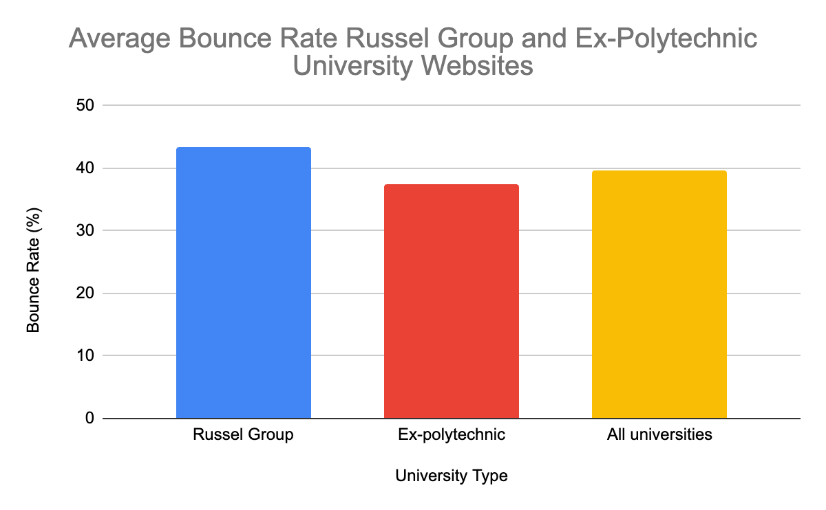

# Appendix B.

## Accessibility of University Website

Bar charts illustrating accessibility levels of UK university websites, specifically Russell Group and ex-polytechnic universities.

### Figure B.1. - Average Number of WAVE Accessibility Issues in Russell Group and Ex-Polytechnic Universities

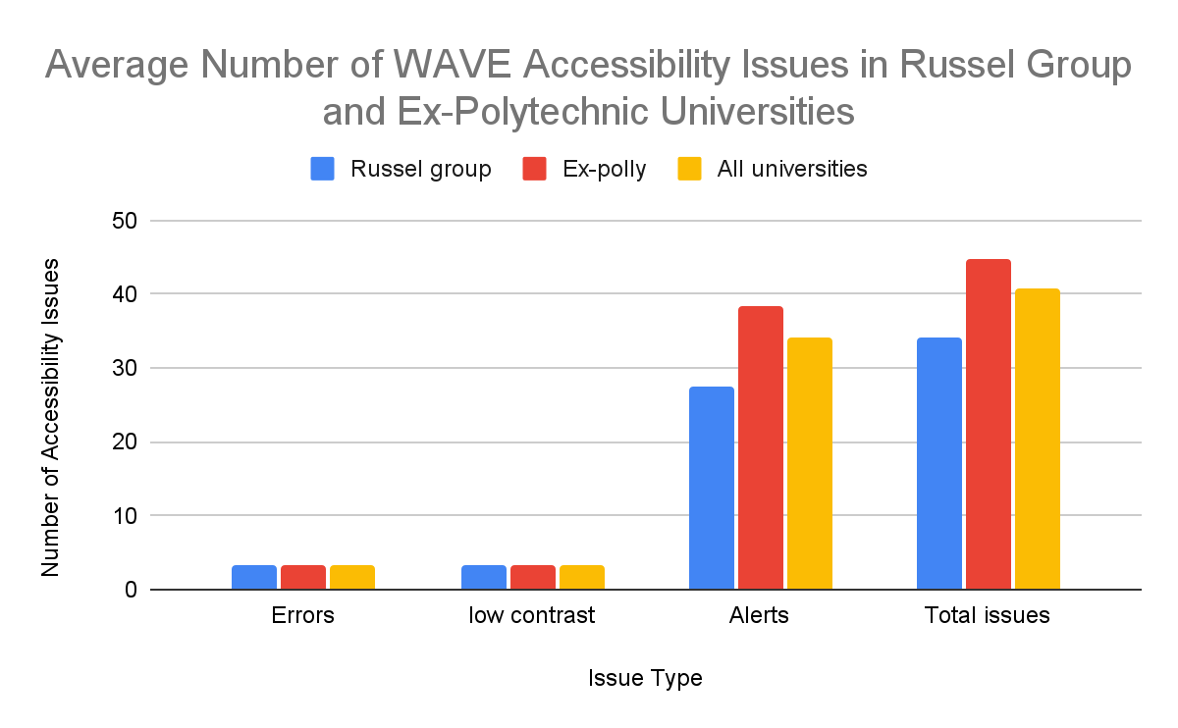

### Figure B.2. - Average Number of WAVE Accessibility Features in Russell Group and Ex-Polytechnic Universities

### ChartFigure B.3. - Average Number of AChecker Accessibility Issues in Russell Group and Ex-Polytechnic Universities

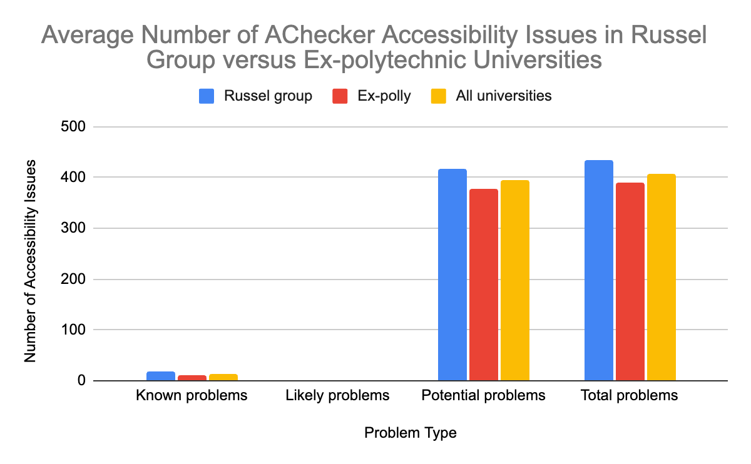

# Appendix C

## Frequency of University Website Accessibility Issues

Bar charts illustrating the frequency of accessibility issues on UK university websites, specifically Russell Group and ex-polytechnic universities.

### Figure C.1. - Frequency of WAVE Accessibility Errors in Russell Group and Ex-Polytechnic Universities

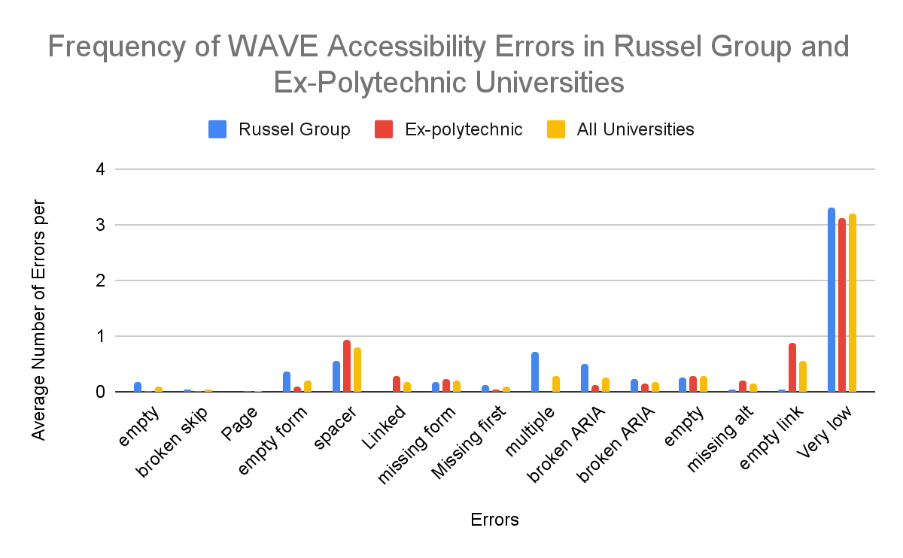

### Figure C.2. - Frequency of WAVE Accessibility Alerts in Russell Group and Ex-Polytechnic Universities

### ChartFigure C.3. - Frequency of Known AChecker Accessibility Issues in Russell Group and Ex-Polytechnic Universities

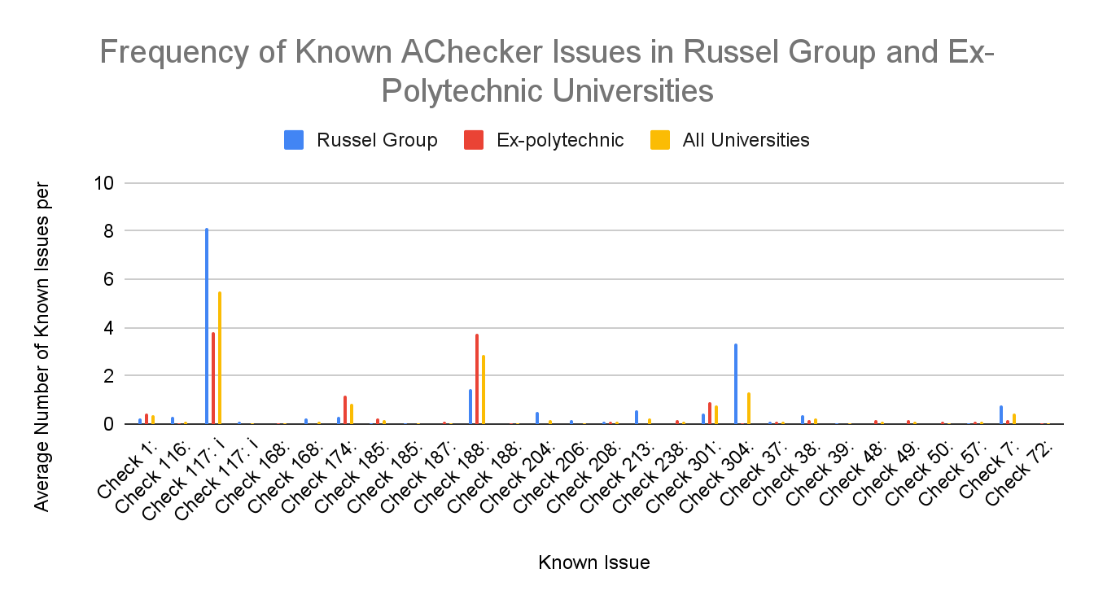

### Figure C.4. - Frequency of Likely AChecker Accessibility Issues in Russell Group and Ex-Polytechnic Universities

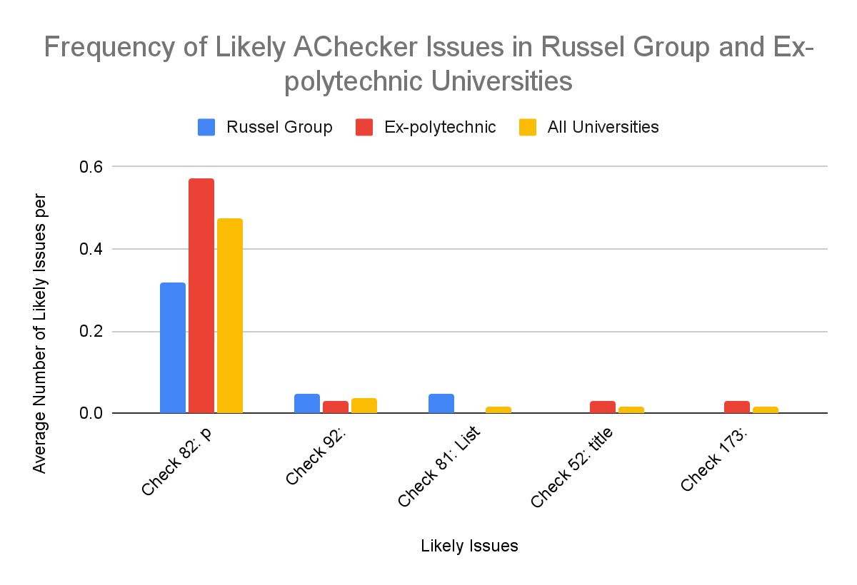

# Appendix D

## Criteria A versus Criteria AA Violations

Bar charts illustrating the distribution of criteria A versus criteria AA violations on UK university websites, specifically Russell Group and Ex-polytechnic universities.

### Figure D.1. - Distribution of Known Issues Across Criteria A versus Criteria AA in Russell Group versus Ex-Polytechnic Universities

### ChartFigure D.2. - Distribution of Likely Issues Across Criteria A versus Criteria AA in Russell Group versus Ex-Polytechnic Universities

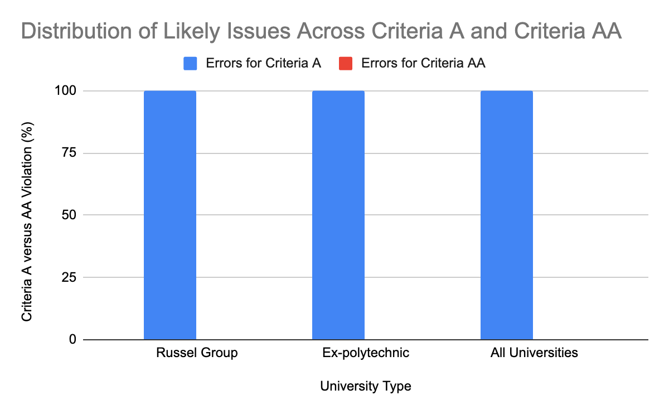

# Appendix E

## Website Accessibility Statements of Universities

Bar charts illustrating the key content in UK university websites accessibility statements, specifically Russell Group and Ex-polytechnic universities.

### Figure E.1. - Compliance of Website Accessibility Statements of Russell Group and Ex-Polytechnic Universities

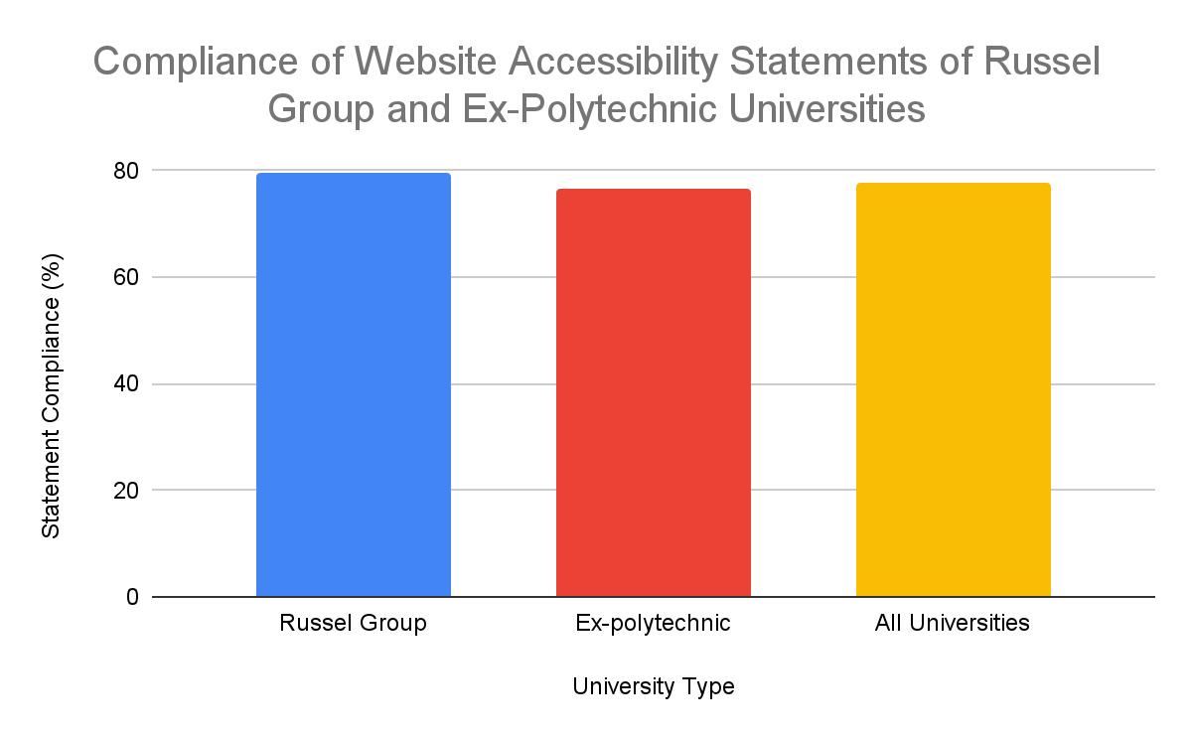

### Figure E.2. - Declared Website Accessibility Compliance Level of Russel Group and Ex-Polytechnic Universities

### ChartFigure E.3. - Percentage of Universities Declaring a Website Accessibility Burden

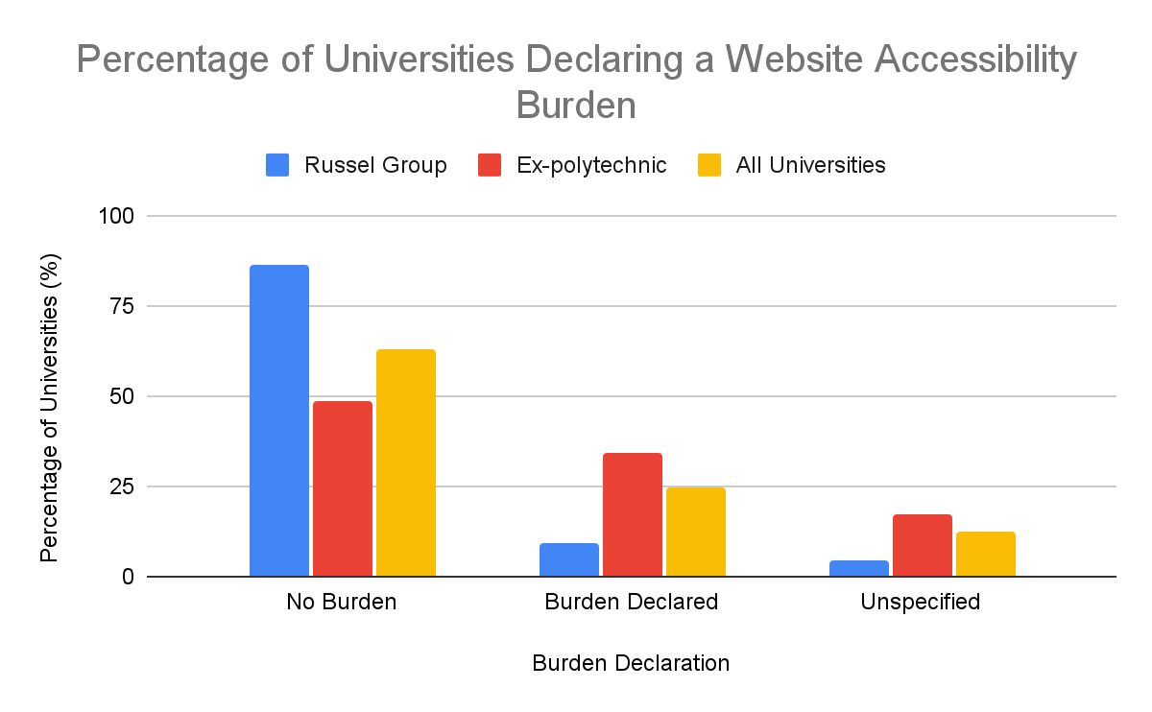

### Figure E.4. - Timeline of Lasts Accessibility Tests at Russell Group and Ex-Polytechnic Universities

The figure below shows the varying intervals since the last in-depth website accessibility testing across Russell Group and ex-polytechnic universities. The time intervals represented in the x-axis are calibrated according to the reference date of August 3, 2024. For example, the category “<1 month” encompasses the period from July 3, 2024, to August 3, 2024. Subsequent categories expand similarly in retrospect from the specified reference date.

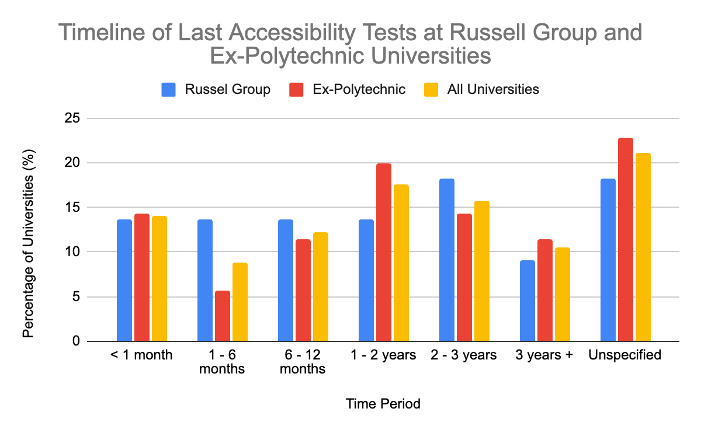

### Figure E.5. - Automated Accessibility Testing Tools Used by Russell Group and Ex-Polytechnic Universities

### ChartFigure E.6. - Website Testing Frequency of Russell Group and Ex-Polytechnic Universities

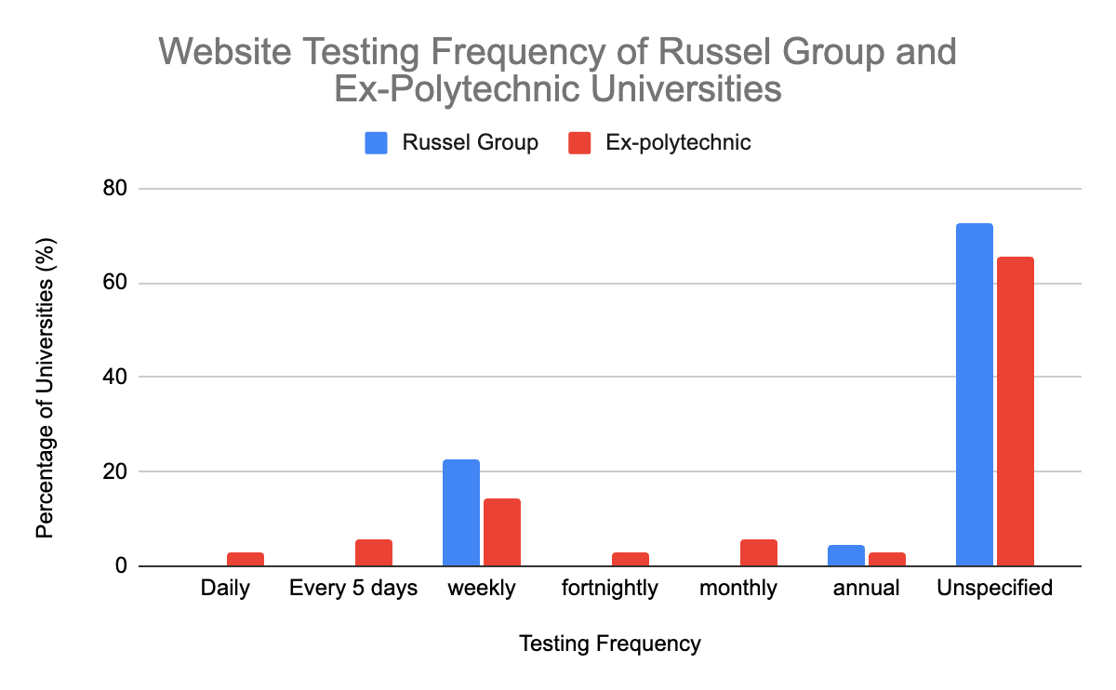

# Appendix F

A correlation heat map. All numbers are rounded to two decimal places for clarity.

## Figure F.1. - Correlation Analysis Heat Map of Russell Group and Ex-Polytechnic University Website Accessibility and Engagement

# Appendix G

A regression coefficient table with model accuracy evaluation including Means Absolute Error, RMSE, Relative Absolute Error, and Root Relative Square Error. All numbers are rounded to two decimal places for clarity.

## Figure - G.1. Regression Coefficient Table of Russell Group and Ex-Polytechnic University Website Accessibility and Engagement

